

COMPLEJIDAD ALGORÍTMICA

Trabajo Parcial

Sección:

Docente: Luis Martín Canaval

Integrantes:

Trujillo Mori, Jeanpier Alexander U201523565

Gray Hidalgo, Alejandro Eduardo U201618549

MAYO 2022

**GRAFO - SAN BORJA**

Por el trabajo parcial del curso de Complejidad Algorítmica, se ha pedido que se usen los temas aprendidos en clase como grafos, matriz de adyacencia, lista de adyacencia, etc. Los grafos son conjuntos de vértices, los cuales se conectan con aristas y se crean relaciones, lo que los hace útiles para la computación, por ejemplo en redes sociales. Para este trabajo se pidió realizar un grafo a base de un distrito de Lima, en este caso San Borja. El objetivo es realizar una aplicación similar a Waze al final de este proyecto

**Marco teórico**

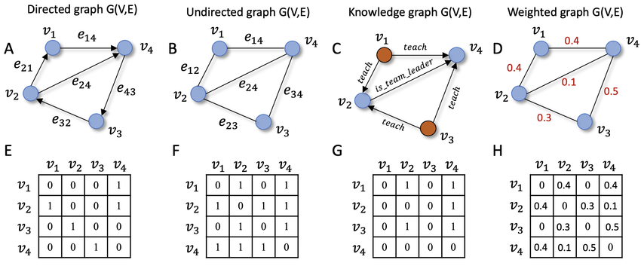

La matriz de adyacencia tiene N filas y columnas, la misma cantidad que el número de vértices. En cada celda se pone un 1 si hay una relación entre los respectivos vértices y 0 de no ser el caso. Si el grafo no es dirigido la matriz será simétrica. Si las aristas tienen pesos estos se pondrán en las celdas en lugar de 1

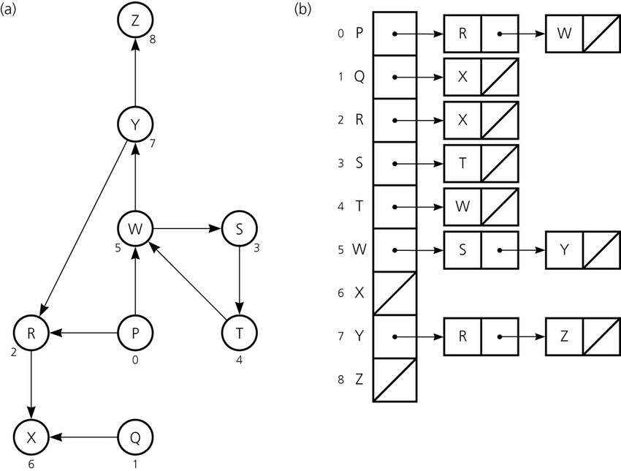

La lista de adyacencia es otra forma de almacenar las relaciones en un grafo. En este caso se crea una lista de tamaño N y cada elemento almacena una lista que incluye los vértices que son adyacentes al actual. Si las aristas tienen pesos entonces la lista será una tupla. La ventaja de las listas de adyacencia es que son más rápidas y funcionan correctamente incluso con números muy grandes

**Estructura de Datos**

**Objetivo:**Representar un grafo del Distrito de San Borja (dividido en sectores)

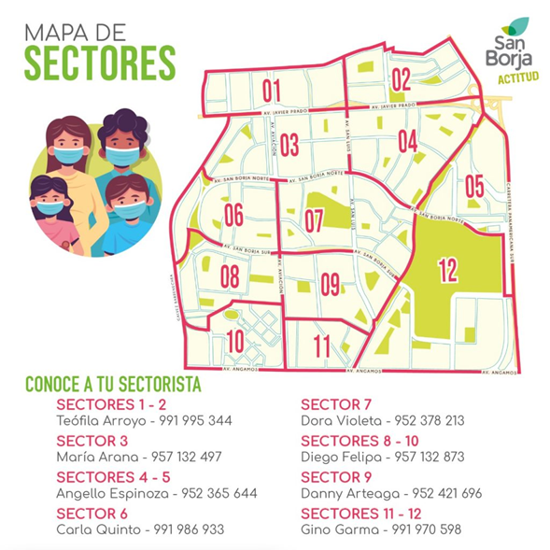

**Estructura de Datos:**Lista de Adyacencia

**Vértice:**Intersección de avenidas del Distrito de San Borja

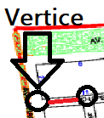

**Arista:**Avenidas que se encuentren entre la intersección de vectores

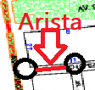

**SECTOR 01**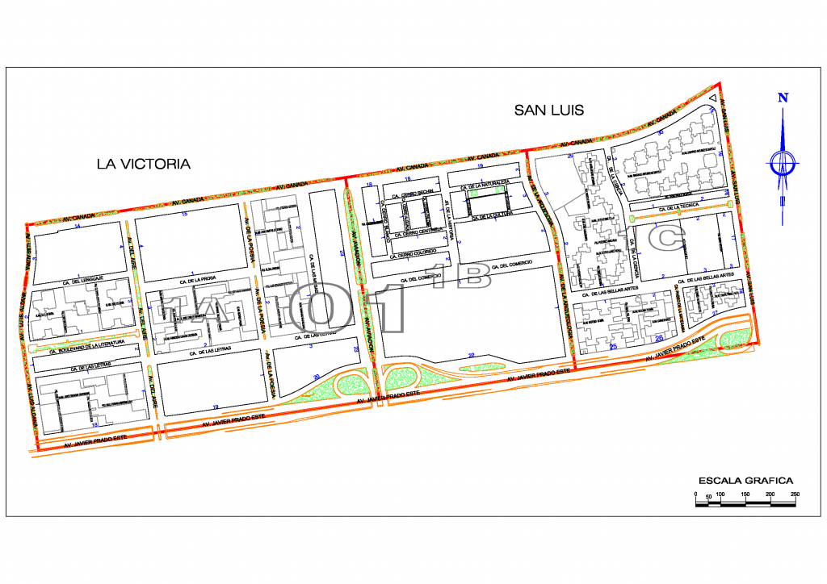

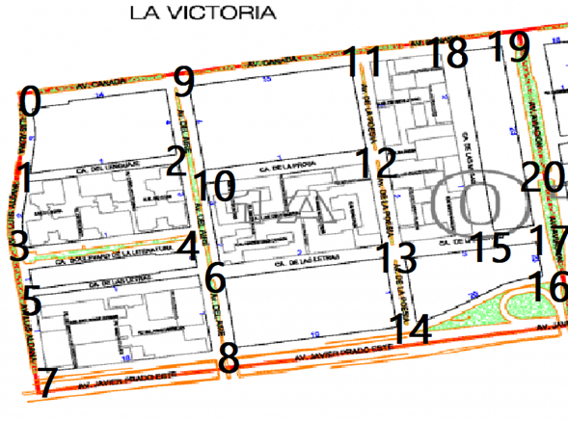

**SECTOR 1A**

[

[1,9], #0

[0,2,3], #1

[1,4,9], #2

[1,4,5], #3

[2,3,6], #4

[3,6,7], #5

[4,5,8], #6

[5,8], #7

[6,7,14], #8

[0,2,10,11], #9

[6,9,12], #10

[9,12,18], #11

[10,11,13], #12

[6,12,14,15], #13

[8,13,16], #14

[13,17,18], #15

[14,17], #16

[15,16,20], #17

[11,15,19], #18

[18,20], #19

[19,17], #20

]

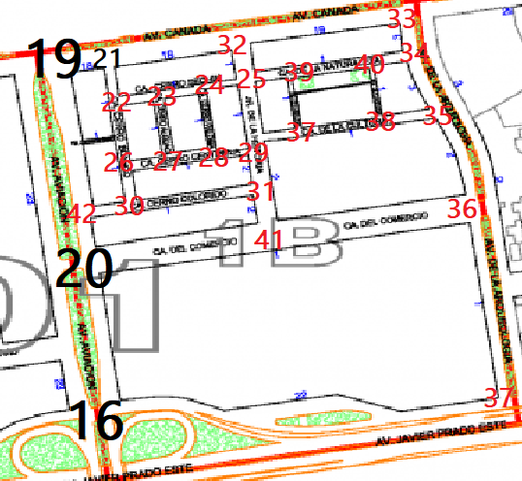

SECTOR 1B

[

[20,37], #16

[20,21], #19

[19,22,32], #21

[21,23,26], #22

[22,24,27], #23

[23,25,28], #24

[24,29,32,39], #25

[22,27,30], #26

[23,26,28], #27

[24,27,29], #28

[25,28,31,37], #29

[26,42,31], #30

[29,30,41], #31

[21,25,33], #32

[32,34], #33

[33,35,40], #34

[34,36,38], #35

[35,37,41], #36

[16,36], #37

[25,27,40], #38

[25,37,40], #39

[34,39,38], #40

[20,31,36], #41

]

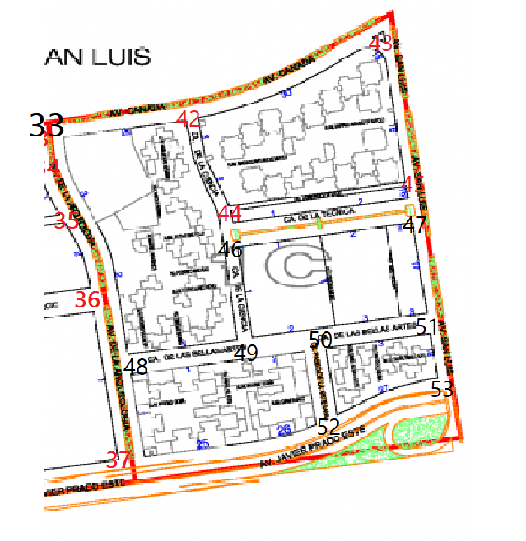

**SECTOR 1C**

[

[42,38], #33

[48,52], #37

[33,43,44], #42

[42,45], #43

[42,45,46], #44

[43,44,47], #45

[44,47,49], #46

[45,46,51], #47

[33,49,37], #48

[48,46,50], #49

[49,51,52], #50

[47,50,53], #51

[37,50,53], #52

]

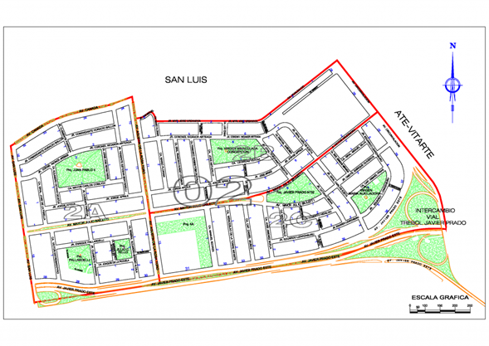

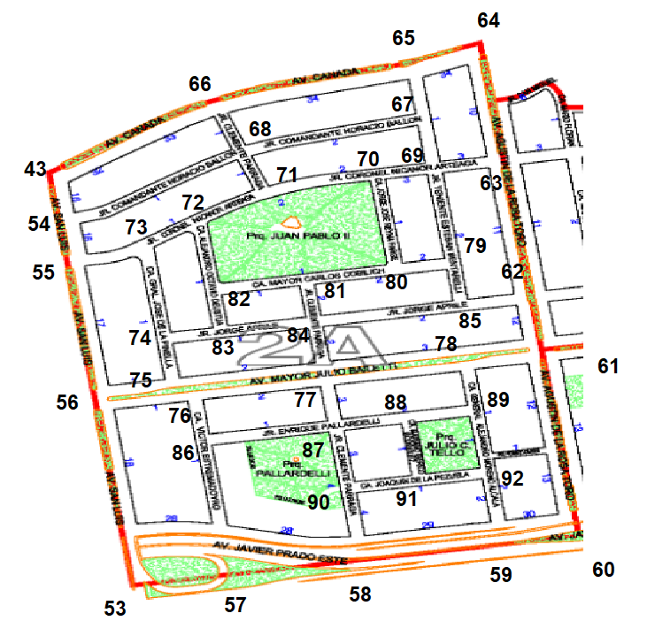

**SECTOR 2A**

[43, 55],#54

[54, 56, 73],#55

[53, 55, 75],#56

[53, 58, 86],#57

[57, 59, 90],#58

[58, 60, 92],#59

[59, 61],#60

[60, 62, 78],#61

[61, 63, 85],#62

[62, 64, 69],#63

[63, 65],#64

[64, 66, 67],#65

[43, 65, 68],#66

[65, 68, 69],#67

[54, 66, 67, 71],#68

[63, 67, 70, 79],#69

[69, 71, 80],#70

[68, 70, 72],#71

[71, 73, 82],#72

[55, 72, 74],#73

[73, 75, 83],#74

[56, 74, 76],#75

[75, 77, 86],#76

[76, 78, 84, 88],#77

[61, 77, 89],#78

[69, 80, 85],#79

[70, 79, 81],#80

[80, 82, 84],#81

[72, 81, 83],#82

[74, 82, 84],#83

[77, 81, 83, 85],#84

[62, 79, 84],#85

[57, 76, 87],#86

[77, 86, 88, 90],#87

[87, 89, 91],#88

[78, 88, 92],#89

[58, 87, 91],#90

[88, 90, 92],#91

[59, 89, 91],#92

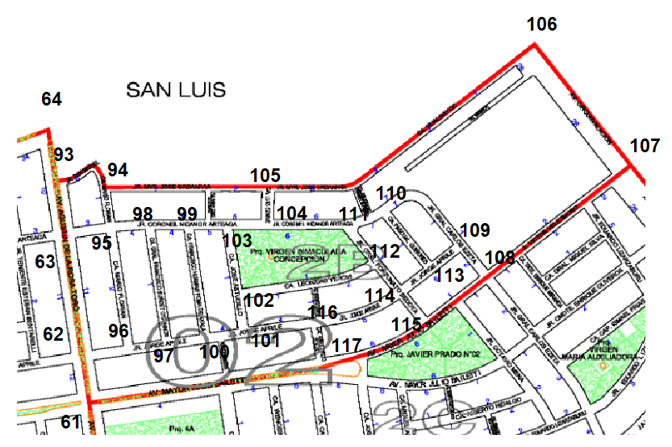

**SECTOR 2B**

[63, 64, 94],#93

[93, 95, 105],#94

[63, 94, 96, 98],#95

[62, 95, 97],#96

[96, 98, 100],#97

[95, 97, 99],#98

[98, 100, 103],#99

[97, 99, 101],#100

[100, 102, 116],#101

[101, 103, 112],#102

[99, 102, 104],#103

[103, 105, 111],#104

[94, 104, 106],#105

[105, 107],#106

[106, 108],#107

[109, 115],#108

[108, 110, 113],#109

[109, 111, 113],#110

[104, 110, 112],#111

[102, 114],#112

[109, 114],#113

[112, 113, 115, 116],#114

[108, 114, 117],#115

[101, 114, 117],#116

[61, 115, 116],#117

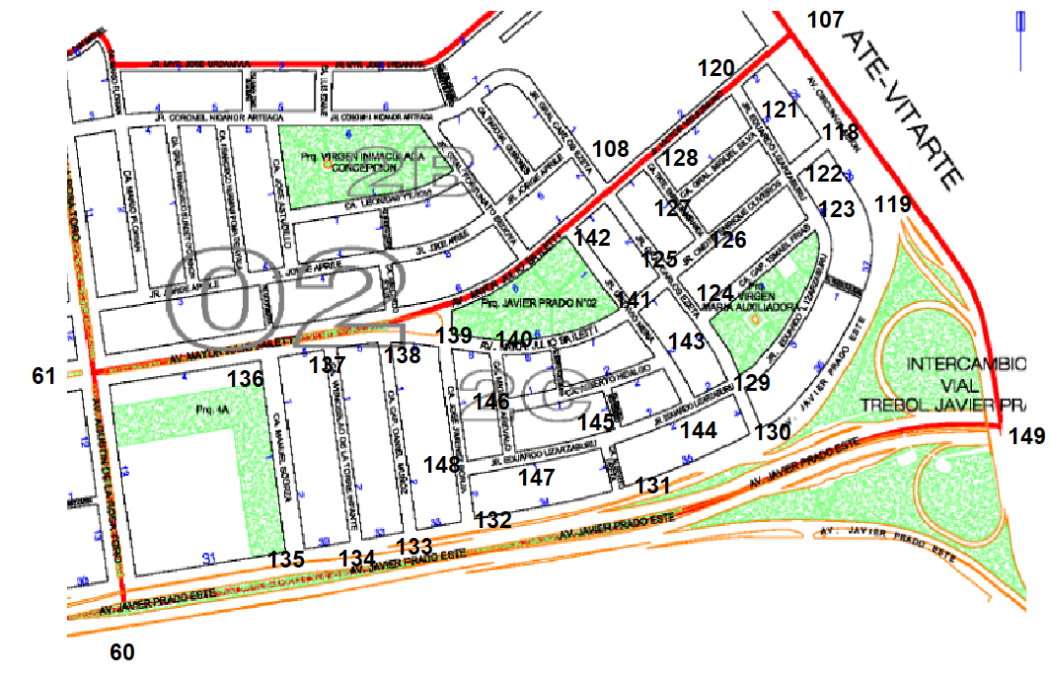

**SECTOR 2C**

[107, 119, 122],#118

[118, 130, 149],#119

[107, 108, 121],#120

[120, 122, 127],#121

[118, 121, 123, 126],#122

[122, 124, 129],#123

[123, 125, 129],#124

[108, 124, 126, 141],#125

[122, 125, 127],#126

[121, 126, 128],#127

[108, 120, 127],#128

[123, 124, 130, 144],#129

[119, 129, 131],#130

[130, 132, 145, 149],#131

[131, 133, 148],#132

[132, 134],#133

[133, 135],#134

[60, 134],#135

[61, 135, 137],#136

[134, 136, 138],#137

[133, 137, 139]#138 ,

[138, 140, 142, 148],#139

[139, 141, 146],#140

[125, 140, 142, 143],#141

[108, 139, 141],#142

[141, 144, 146],#143

[129, 143, 145],#144

[131, 144, 147],#145

[140, 143, 147],#146

[145, 146, 148],#147

[132, 139, 147],#148

[119, 131],#149

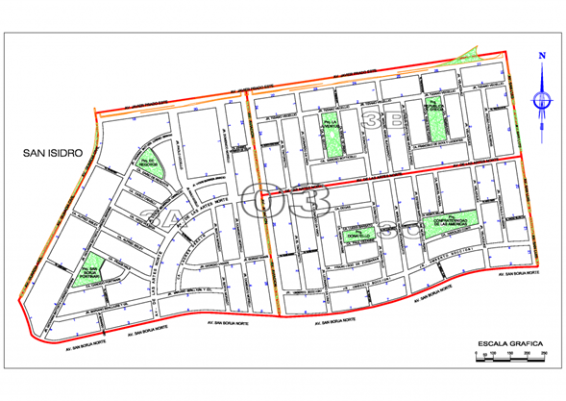

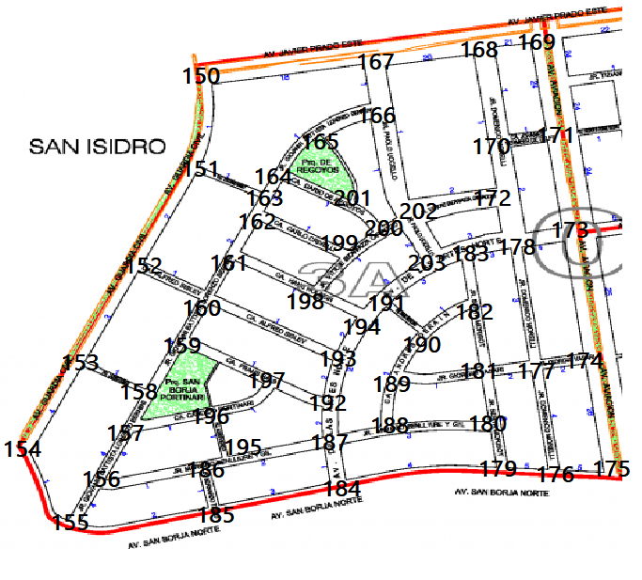

**Sector 3A**

[

[151,167], #150

[150,163,152], #151

[151,160,153], #152

[152,158,154], #153

[153,155], #154

[154,156,185], #155

[155,157,186], #156

[156,158,196], #157

[153,157,159], #158

[158,160,197], #159

[15,159,161,193], #160

[160,162,198], #161

[163,161,199], #162

[151,164,162], #163

[163,165,201], #164

[164,166,201], #165

[165,167,202], #166

[150,168,166], #167

[167,169,170], #168

[168,171], #169

[168,171,17], #170

[169,170,173], #171

[170,202,178], #172

[178,171,174], #173

[173,177,175], #174

[174,176], #175

[177,179,175], #176

[178,174,181,176], #177

[172,183,177,173], #178

[180,184,176], #179

[181,188,179], #180

[182,189,177,180], #181

[183,190,181], #182

[203,182,178], #183

[185,187,179], #184

[155,186,184], #185

[156,185,195], #186

[195,192,188,184], #187

[189,187,180], #188

[190,181,188], #189

[191,182,189], #190

[194,203,190], #191

[197,187,193], #192

[194,192,160], #193

[198,191,193], #194

[186,196,187], #195

[157,197,195], #196

[159,192,196], #197

[199,194,161], #198

[162,198,200], #199

[201,199,202], #200

[164,165,200], #201

[166,200,172,203], #202

[202,200,183,191], #203

]

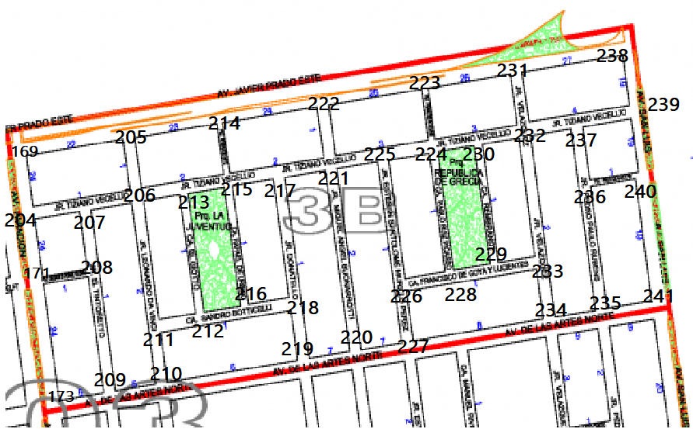

**Sector 3B**

[

[205,204], #169

[204,208,173], #171

[171,209], #173

[169,171,207], #204

[169,206,214], #205

[205,207,213,211], #206

[204,208,206], #207

[171,207,209], #208

[208,173,210], #209

[209,211,219], #210

[210,206,212], #211

[211,213,216], #212

[206,215,212], #213

[205,222,215], #214

[214,213,216,217], #215

[214,212,218], #216

[215,221,218], #217

[216,217,219], #218

[218,210,220], #219

[219,227,221], #220

[222,217,220,225], #221

[214,221,223], #222

[222,231,224], #223

[223,225,230,228], #224

[221,224,226], #225

[225,228,227], #226

[220,226,234], #227

[226,229,224], #228

[228,230,233], #229

[224,232,229], #230

[223,238,232], #231

[231,230,237,233], #232

[229,232,234], #233

[233,227,235], #234

[234,236,241], #235

[237,240,235], #236

[232,236,239], #237

[231,239], #238

[238,237,240], #239

[236,239,241], #240

[235,240], #241

]

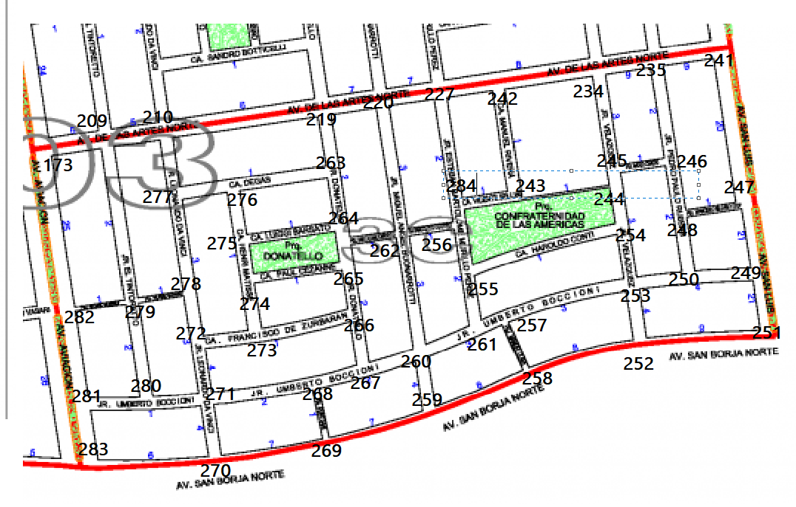

**Sector 3C**

[

[209,282],#173

[173,210,279],#209

[209,277,219],#210

[235,247],#241

[227,243,234],#242

[242,284,244],#243

[245,254],#244

[234,244,246],#245

[235,245,248],#246

[241,248,249],#247

[246,247,250],#248

[250,247,251],#249

[248,253,249],#250

[249,252],#251

[254,251,258],#252

[254,250,252,257],#253

[244,255,253],#254

[256,261,257],#255

[284,255,262],#256

[261,253,258],#257

[7257,259,252],#258

[260,269,258],#259

[267,259,261],#260

[255,257,260],#261

[256,220,260,264],#262

[219,276,264],#263

[263,262,275],#264

[262,274,266],#265

[265,273,267],#266

[266,260,268],#267

[271,267,269],#268

[268,259,270],#269

[283,271,269],#270

[280,272,268,270],#271

[273,278,271],#272

[272,274,266],#273

[273,275,265],#274

[276,264,274],#275

[277,263,275],#276

[210,276,278],#277

[279,272,277],#278

[282,278,209,280],#279

[279,281,271],#280

[282,280,283],#281

[173,279,281],#282

[281,270],#283

[227,243,256],#284

]

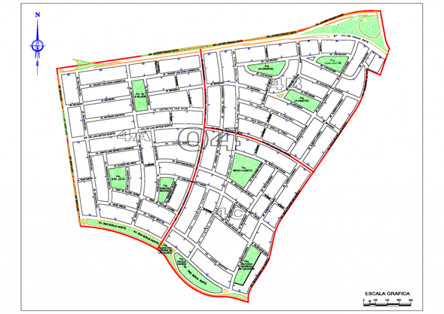

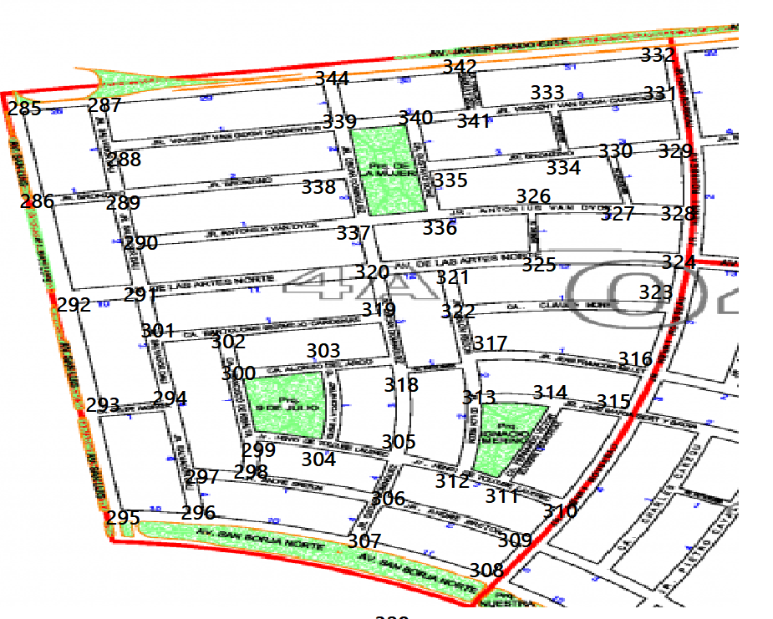

**SECTOR 4A:**

[

[287,286],#285

[285,289,292],#286

[285,344,288],#287

[287,289,339],#288

[288,286,290,338],#289

[289,337,291],#290

[290,292,329,301],#291

[286,291,293],#292

[292,294,295],#293

[301,293,297],#294

[293,296],#295

[295,297,307],#296

[294,298,296],#297

[297,299,306],#298

[300,304,298],#299

[302,299,303],#300

[291,294,302],#301

[300,301,319],#302

[300,304,318],#303

[303,299,305],#304

[304,318,312,306],#305

[305,298,309,307],#306

[306,296,308],#307

[308,309],#308

[306,308,310],#309

[311,309,315],#310

[312,314,310],#311

[305,313,311],#312

[317,314,312],#313

[313,315,311],#314

[314,316,310],#315

[315,317,323],#316

[322,316,313],#317

[305,303,319],#318

[320,302,318],#319

[337,291,319,321],#320

[320,322,325],#321

[321,317,323],#322

[322,324,316],#323

[325,328,324],#324

[321,326,324],#325

[336,325,327],#326

[326,330,328],#327

[324,327,329],#328

[330,328,331],#329

[334,327,329],#330

[332,333,329],#331

[342,331],#332

[341,334,331],#333

[335,333,330],#334

[340,336,334],#335

[337,334,326],#336

[338,290,336,320],#337

[3289,339,337],#338

[344,288,340,338],#339

[339,335,341],#340

[340,342,333],#341

[344,341,332],#342

[340,290],#343

[287,342,339],#344

]

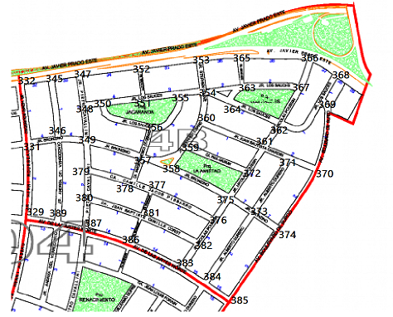

**Sector 4B**

[

[389,331],#329

[329,346],#331

[345,331],#332

[332,346,347],#345

[345,331,349,389],#346

[345,352,348],#347

[347,350,349],#348

[348,346,357,379],#349

[348,351,356],#350

[352,350,355],#351

[347,351,353],#352

[352,354,365],#353

[355,353,360,363,364],#354

[351,356,354],#355

[350,355,357],#356

[349,356,358,378],#357

[359,357,375],#358

[357,358,360],#359

[354,359,361],#360

[362,360,371,372],#361

[361,364,367,369],#362

[364,354,365,367],#363

[354,363,362],#364

[353,363,366],#365

[365,367,368],#366

[365,367,368],#366

[363,366,362],#367

[366,369],#368

[368,362,370],#369

[371,369,374],#370

[361,370,373],#371

[359,361,375],#372

[371,375,374,384],#373

[370,373,385],#374

[372,358,373,376],#375

[375,377,382],#376

[378,381,376],#377

[377,357,379],#378

[349,378,380],#379

[379,381,387],#380

[377,382,386,380],#381

[376,381,383],#382

[382,386,384],#383

[385,373,383],#384

[383,374],#385

[383,381,387],#386

[380,385,389],#387

[389,387],#388

[329,346,387,388],#389

]

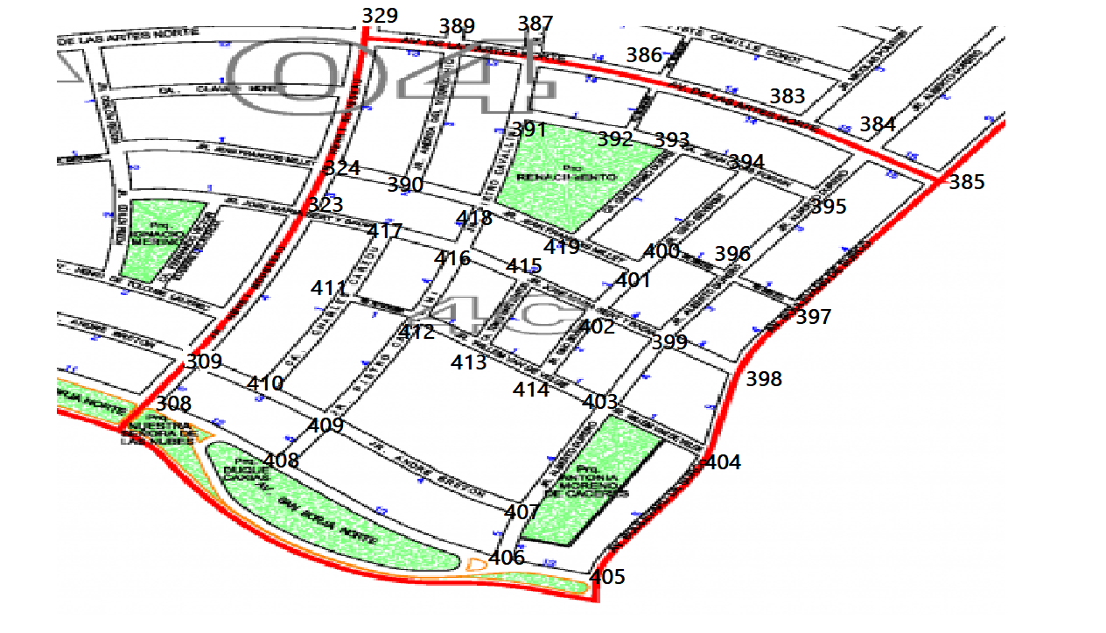

**Sector 4C**

[

[309,408],#308

[410,323],#309

[324,417,309],#323

[323,390,329],#324

[324,389],#329

[329,387,390],#389

[389,386,391],#387

[387,383,392],#386

[386,384],#383

[393,395,385],#384

[384,397],#385

[389,324,418],#390

[387,392,418,390],#391

[391,393,386],#392

[392,394,419],#393

[393,400,395],#394

[394,384,396],#395

[395,397,400,399],#396

[396,385,398],#397

[397,399,404],#398

[398,396,402,403],#399

[401,396,394],#400

[400,402,419],#401

[401,399,414,415],#402

[414,499,404,407],#403

[398,305,403],#404

[405,406],#405

[405,407,408],#406

[406,403,409],#407

[406,409,309],#408

[408,410,412,407],#409

[417,412,410],#411

[411,416,413,409],#412

[412,415,414],#413

[413,402,403],#414

[416,413,402],#415

[418,417,415,412],#416

[323,411,416],#417

[390,416,419,391],#418

[418,393,401],#419

]

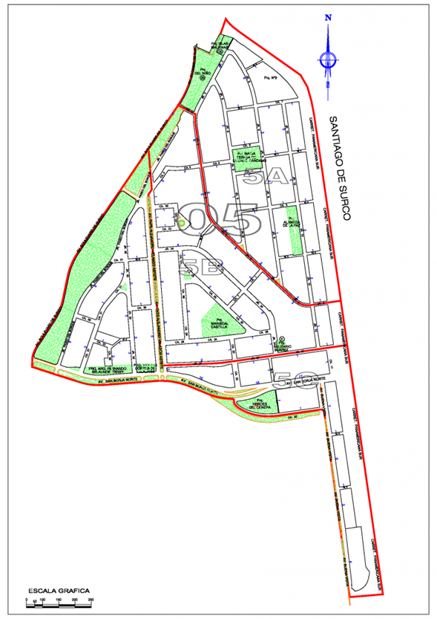

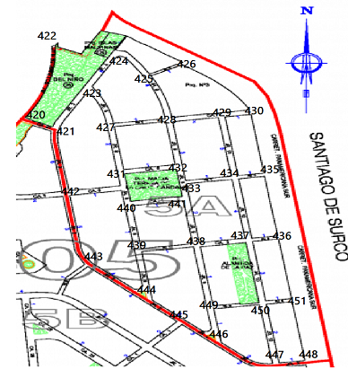

**Sector 5A**

[

[422],#420

[420,423,442],#421

[420],#422

[424,421,427],#423

[423,425],#424

[424,426,428],#425

[425,430],#426

[423,428,431],#427

[425,429,427,432],#428

[430,428,434],#429

[429,435,426],#430

[427,432,440,442],#431

[431,433,428],#432

[432,434,441],#433

[429,433,435,537],#434

[430,434,436],#435

[437,435,451],#436

[438,434,436,450],#437

[441,439,437,449],#438

[440,438,444],#439

[431,441,439],#440

[433,440,438],#441

[431,443,421],#442

[442,444],#443

[443,439,445],#444

[444,446],#445

[445,449,447],#446

[446,450,448],#447

[447,451],#448

[446,450,438],#449

[449,437,451,447],#450

[450,436,448],#451

]

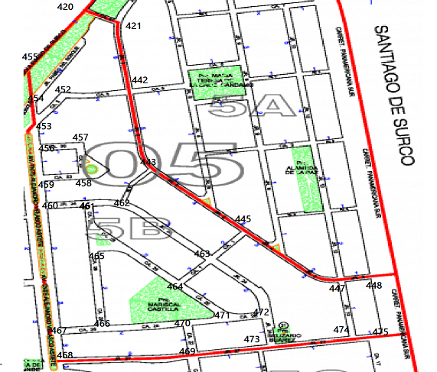

**Sector 5B**

[

[421,455],#420

[420,442],#421

[421,452,443],#442

[442,462,445],#443

[443,463,447],#445

[445,448,474],#447

[447,425],#448

[453,442],#452

[454,452,456],#453

[455,453],#454

[420,454],#455

[453,457,459],#456

[456,458],#457

[457,459],#458

[456,458,460],#459

[459,461],#460

[460,462,465],#461

[461,443,463],#462

[462,445,472,464],#463

[463,465,461,471],#464

[461,464,466],#465

[465,470,467],#466

[465,460,468],#467

[467,469],#468

[468,470,473],#469

[466,470,469],#470

[470,464,472],#471

[471,463,473],#472

[469,472,474],#473

[447,475,473],#474

[474,448],#475

]

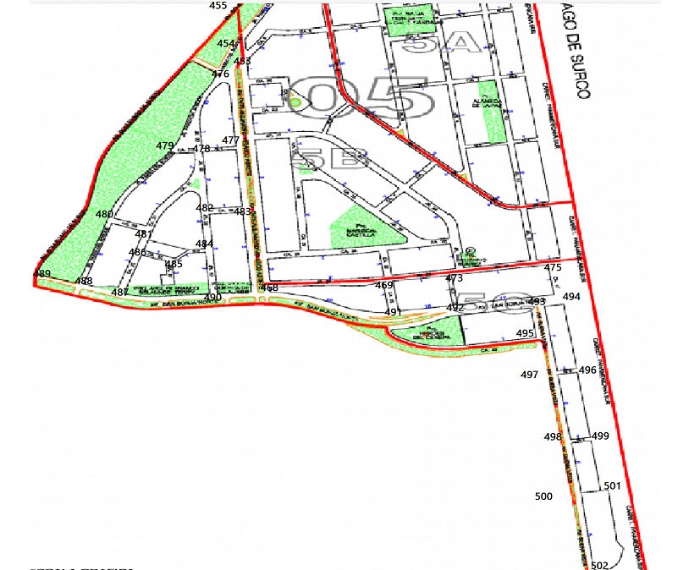

**Sector 5C**

[

[476,468],#453

[455,476],#454

[489],#455

[453,469,490],#468

[469,491,473],#469

[469,492,475],#473

[494,473],#475

[454,453,479,478],#476

[478,476,483],#477

[479,477,482],#478

[478,476,480],#479

[479,481,488],#480

[480,486,478],#481

[478,483,484],#482

[482,477,468],#483

[482,485,490],#484

[484,486],#485

[481,485,487],#486

[486,488,490],#487

[489,485,480],#488

[488,455],#489

[487,484,468],#490

[469,492,468],#491

[473,491,493],#492

[492,495,494],#493

[473,493,496],#494

[493,497],#495

[494,497,499],#496

[495,496,498],#497

[497,499,500],#498

[498,496,501],#499

[498,502],#500

[499,502],#501

[500,501],#502

]

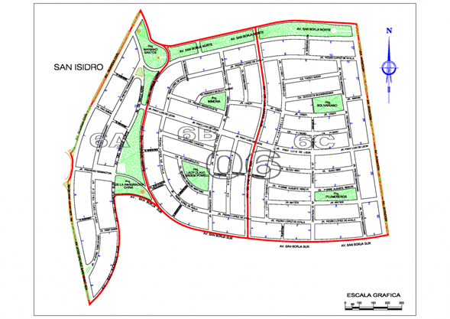

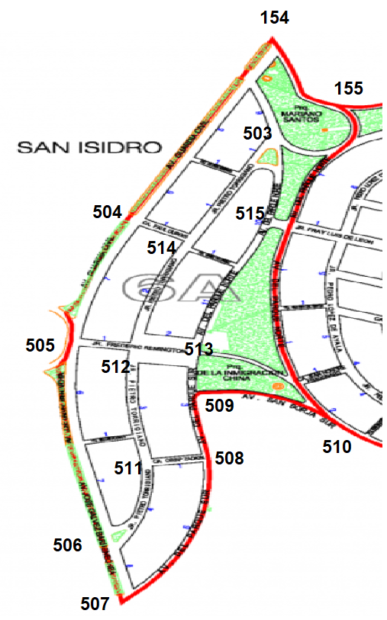

**SECTOR 6A**

#503 [154, 155, 513, 514, 515]

#504 [154, 505, 514]

#505 [504, 506, 512]

#506 [505, 507, 511]

#507 [506, 508]

#508 [507, 509, 511]

#509 [508, 510, 513]

#510 [509, 515]

#511 [506, 508, 512]

#512 [505, 511, 513]

#513 [509, 512, 515]

#514 [503, 504, 512, 515]

#515 [503, 510, 513]

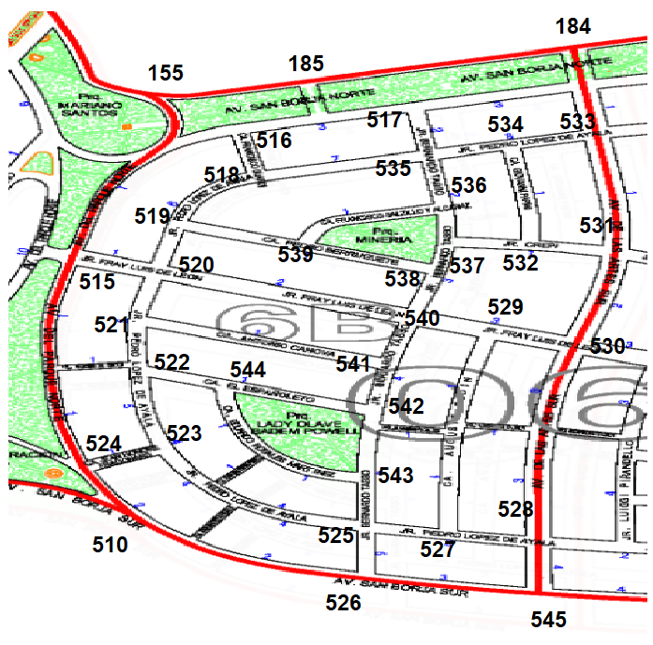

**SECTOR 6B:**

#516 [155, 185, 518]

#517 [184, 185, 535]

#518 [516, 519, 535]

#519 [518, 520, 539]

#520 [515, 519, 521, 540]

#521 [515, 522, 541]

#522 [521, 523, 544]

#523 [522, 524, 525]

#524 [510, 515, 523]

#525 [523, 526, 527, 543]

#526 [510, 525, 545]

#527 [525, 528, 529]

#528 [527, 530, 545]

#529 [527, 530, 540]

#530 [528, 529, 531]

#531 [530, 532, 533]

#532 [531, 534, 537]

#533 [184, 531, 534]

#534 [532, 533, 535]

#535 [517, 518, 534, 536]

#536 [535, 537, 539]

#537 [532, 536, 538]

#538 [537, 539, 540]

#539 [519, 536, 538]

#540 [520, 530, 537, 541]

#541 [521, 540, 542]

#542 [541, 543, 544]

#543 [525, 542, 544]

#544 [522, 542, 543]

#545 [526, 528]

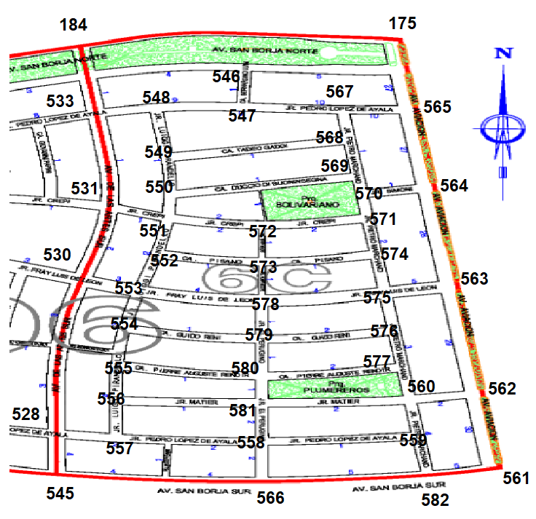

**SECTOR 6C**

#546 [175, 184, 547]

#547 [546, 548, 567]

#548 [533, 547, 549]

#549 [548, 550, 568]

#550 [551, 569]

#551 [531, 550, 552, 572]

#552 [551, 553, 573]

#553 [530, 552, 554, 578]

#554 [553, 555, 579]

#555 [554, 556, 580]

#556 [555, 557, 581]

#557 [528, 556, 558]

#558 [557, 559, 566, 581]

#559 [558, 560, 582]

#560 [559, 562, 577, 581]

#561 [562, 582]

#562 [560, 561, 563]

#563 [562, 564, 575]

#564 [563, 565, 570]

#565 [175, 564, 567]

#566 [545, 558, 582]

#567 [547, 565, 568]

#568 [549, 567, 569]

#569 [550, 568, 570]

#570 [564, 569, 571]

#571 [570, 572, 574]

#572 [551, 571, 573]

#573 [552, 572, 574, 578]

#574 [571, 573, 575]

#575 [563, 574, 576, 578]

#576 [575, 577, 579]

#577 [560, 576, 580]

#578 [553, 573, 575, 579]

#579 [554, 576, 578, 580]

#580 [555, 577, 579, 581]

#581 [556, 558, 560, 580]

#582 [559, 561, 566]

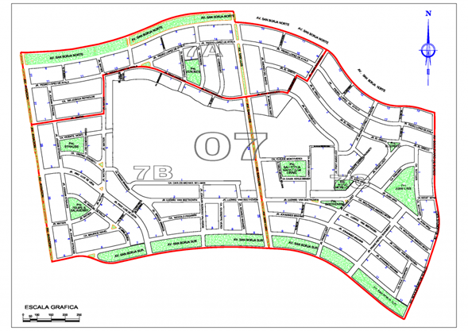

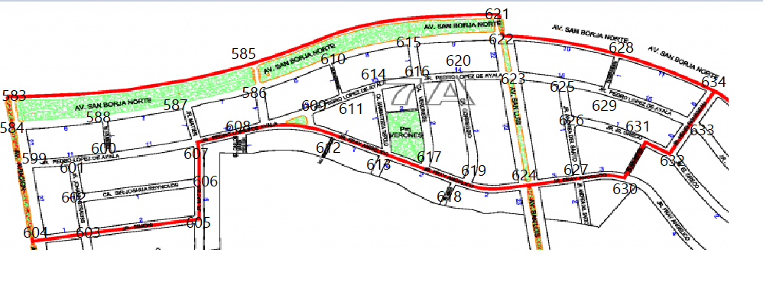

**Sector 7A**

[

[584,585],#583

[583,588],#584

[583,586,621],#585

[585,587,610,609],#586

[588,607,586],#587

[584,600,587],#588

[560,600,592],#589

[600,591,593],#590

[590,592,594],#591

[592,591,589,596],#592

[590,592,594],#593

[593,595,591],#594

[594,596],#595

[595,592,598,596],#596

[596,598],#597

[597,596,599],#598

[584,599,600,604],#599

[601,588,607],#600

[599,602,600],#601

[601,606,603],#602

[602,604,605],#603

[599,603],#604

[606,603],#605

[607,605,602],#606

[600,587,606,608],#607

[600,612,607,586],#608

[608,614,610],#609

[586,615,611],#610

[609,610,614],#611

[612,608,613],#612

[612,614,617],#613

[611,616,613],#614

[610,616,622],#615

[615,614,620,617],#616

[613,618,616],#617

[619],#618

[617,618,620,624],#619

[616,623,619],#620

[585,622],#621

[621,615,623,628],#622

[620,622,625,624],#623

[619,627,623],#624

[623,629,626],#625

[625,631,627],#626

[624,626,630],#627

[622,629,634],#628

[625,628,633],#629

[627,631],#630

[626,632,630],#631

[633,631],#632

[634,629,632],#633

[628,633],#634

]

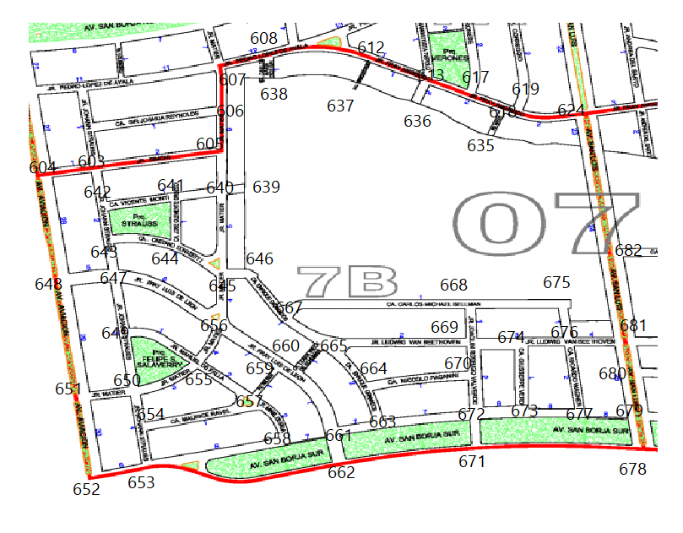

**Sector 7B**

[

[604,642,605],#603

[603,648],#604

[606,640,603],#605

[605,607],#606

[606,608],#607

[638],#608

[637,608,613],#612

[612,636,617],#613

[613,618],#617

[617,619,635],#618

[618,624],#619

[619,682],#624

[618],#635

[613],#636

[612],#637

[608],#638

[640],#639

[605,641,645,639],#640

[642,640,644],#641

[603,641,643],#642

[647,642,644],#643

[643,641,645],#644

[644,646,640,656],#645

[645,667],#646

[643,658,656,649],#647

[604,647,651],#648

[647,650,655],#649

[649,655,651,654],#650

[548,650,652],#651

[651,653],#652

[652,662,654],#653

[650,657,653],#654

[656,650,657,649],#655

[647,645,659,655],#656

[659,655,658,654],#657

[657,653],#658

[657,660,656],#659

[659,665,661],#660

[662,663,660],#661

[661,671,653],#662

[661,664,672],#663

[665,670,663],#664

[660,666,667,669,664],#665

[665,667],#666

[666,646,668,665],#667

[669,675,667],#668

[670,674,665],#669

[669,672,664],#670

[672,662,678],#671

[663,670,673],#672

[672,674,677],#673

[673,669,676],#674

[668,676],#675

[674,675,681,677],#676

[673,676],#677

[679,671],#678

[680,678],#679

[679,676,681],#680

[676,680,682],#681

[681,624],#682

]

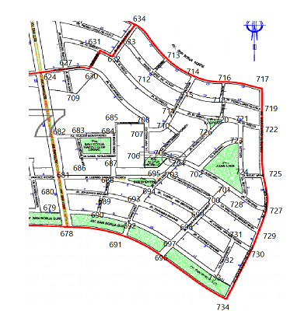

**Sector 7C**

[

[691,679],#678

[690,680],#679

[681,689],#680

[688,682],#681

[682,627],#624

[624,709],#627

[708,631],#630

[630,632],#631

[631,633,711],#632

[632,634,712],#633

[633,713],#634

[683,624],#682

[682,684,686],#683

[683,685,687],#684

[684,708],#685

[683,687],#686

[686,684,688],#687

[687,681,695,694,689],#688

[688,693,680,690],#689

[689,692,679],#690

[692,678,696],#691

[691,690,693,697],#692

[694,689,698,692],#693

[693,703,688,699],#694

[694,703,688],#695

[697,691,734],#696

[696,692,733,698],#697

[699,732,697,693],#698

[700,731,698,693],#699

[729,701,699,703],#700

[700,702,728],#701

[701,704,723],#702

[696,704,700],#703

[725,723,728],#704

[706,710,704],#705

[707,705],#706

[708,710,706],#707

[707,630],#708

[701,705],#709

[709,707,711],#710

[710,715,632,626,720],#711

[633,713,715],#712

[714,712,634],#713

[713,716,715],#714

[714,712,718,711],#715

[714,717,718],#716

[716,719],#717

[716,715,719,720],#718

[717,722,718],#719

[721,718,726,714],#720

[720,723,722],#721

[719,721,725],#722

[721,724,702],#723

[723,725,728],#724

[724,727,722],#725

[720,714,704],#726

[725,729,728],#727

[701,724,727],#728

[727,730,700],#729

[731,729,734],#730

[730,732,699],#731

[731,698,733],#732

[732,697],#733

[696,730],#734

]

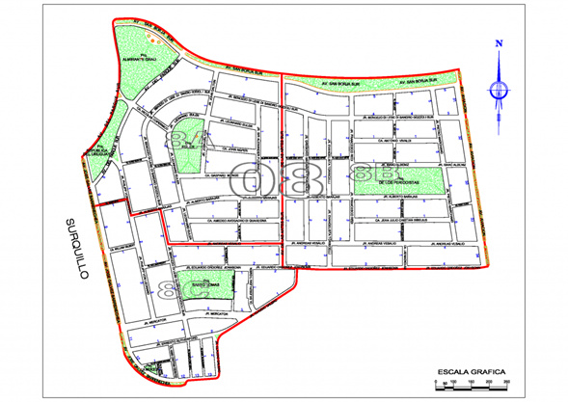

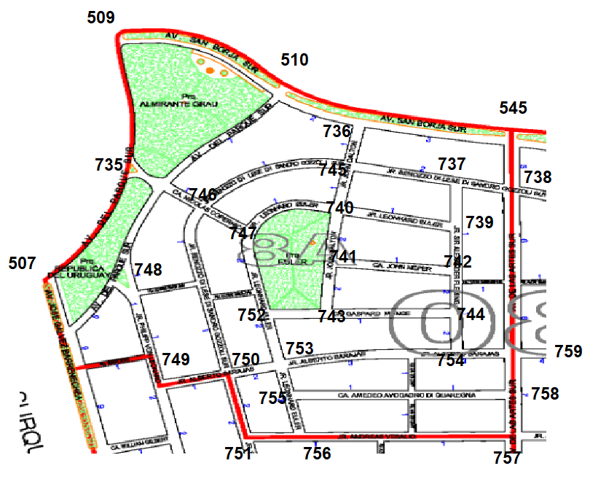

**SECTOR 8A**

[507, 509, 510, 746, 748],#735

[510, 545, 745],#736

[738, 739, 745],#737

[545, 737, 759],#738

[737, 740, 742],#739

[739, 741, 745, 747],#740

[740, 742, 743],#741

[739, 741, 744],#742

[741, 744, 752],#743

[742, 743, 754],#744

[736, 737, 740, 746],#745

[735, 745, 747, 750],#746

[740, 746, 752],#747

[507, 735, 746, 749],#748

[748, 750],#749

[746, 749, 751, 753],#750

[750, 756],#751

[743, 747, 753],#752

[750, 752, 754, 755],#753

[744, 753, 759],#754

[753, 756, 758],#755

[751, 755, 757],#756

[756, 758],#757

[755, 757, 759],#758

[738, 754, 758],#759

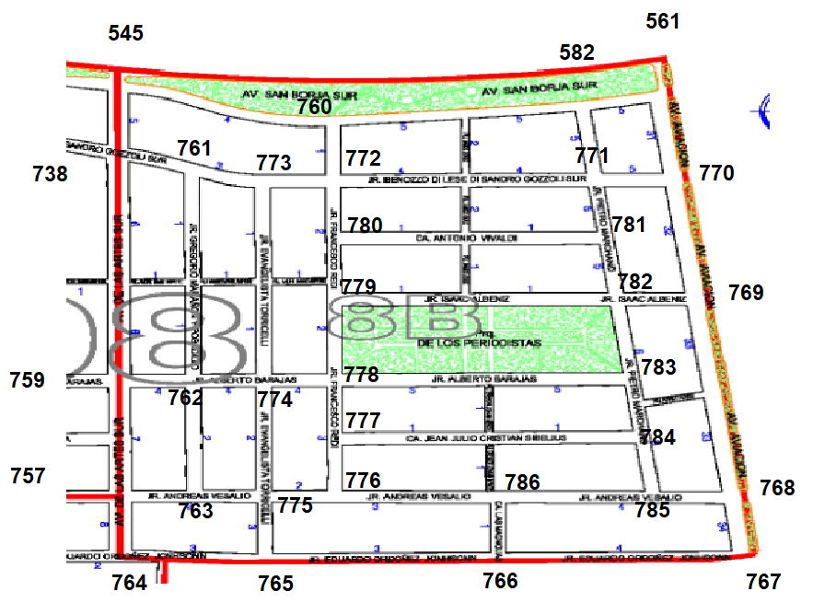

**SECTOR 8B**

[545, 582, 772],#760

[738, 762, 773],#761

[759, 761, 763, 774],#762

[757, 762, 775]#763

[757, 765]#764

[764, 766, 775]#765

[765, 767, 786]#766

[766, 768]#767

[767, 769, 785]#768

[768, 770, 782]#769

[561, 769, 771]#770

[582, 770, 772, 781]#771

[760, 771, 773, 780]#772

[761, 772, 774]#773

[763, 773, 775, 778]#774

[763, 765, 774, 776]#775

[775, 777, 786]#776

[776, 778, 784]#777

[774, 777, 779, 783]#778

[778, 780, 782]#779

[772, 779, 781]#780

[771, 780, 782]#781

[769, 779, 781, 783]#782

[778, 782, 784]#783

[777, 783, 785]#784

[768, 784, 786]#785

[766, 776, 785]#786

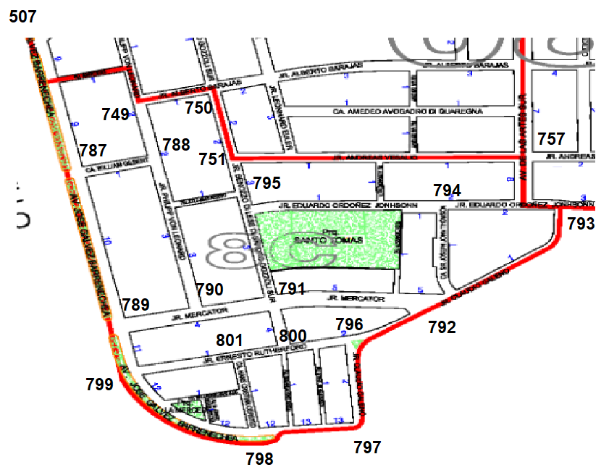

**SECTOR 8C**

[507, 749, 789],#787

[749, 787, 790],#788

[787, 790, 799],#789

[788, 789, 791],#790

[790, 792, 795, 800],#791

[791, 793, 794, 796],#792

[757, 792, 794],#793

[792, 793, 795],#794

[751, 794, 794],#795

[792, 797, 800],#796

[796, 798],#797

[797, 799, 801],#798

[789, 798, 801],#799

[791, 796, 801],#800

[798, 799, 800],#801

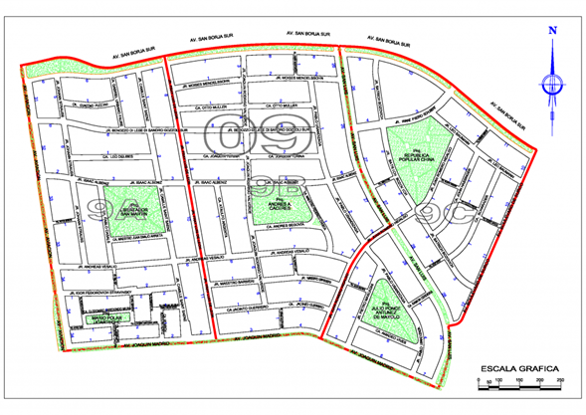

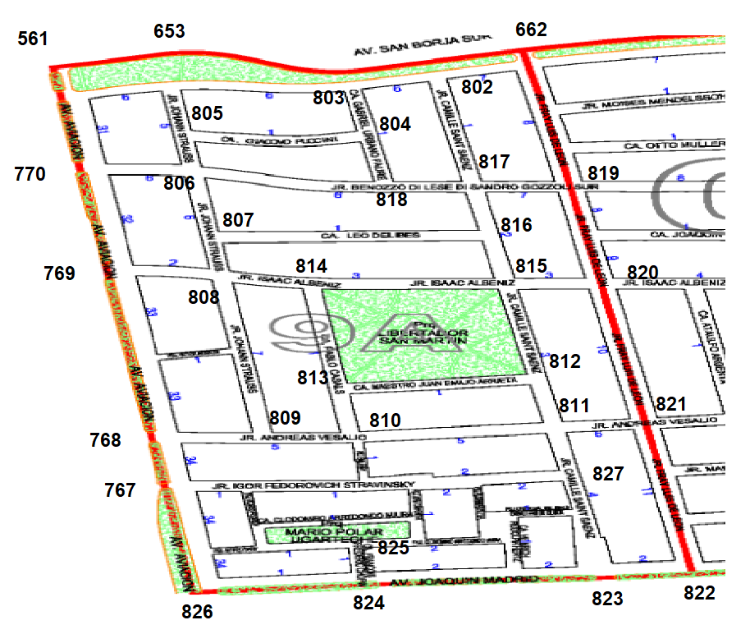

**SECTOR 9A**

[662, 803, 817],#802

[653, 802, 804],#803

[803, 805, 818],#804

[653, 803, 806],#805

[770, 805, 807, 818],#806

[806, 808, 816],#807

[769, 807, 809, 814],#808

[768, 808, 810],#809

[809, 811, 813],#810

[810, 812, 821, 827],#811

[811, 813, 815],#812

[810, 812, 814],#813

[808, 813, 815],#814

[812, 814, 816, 820],#815

[807, 815, 817],#816

[802, 816, 818, 819],#817

[804, 806, 817],#818

[662, 817, 820],#819

[815, 819, 821],#820

[811, 820, 822],#821

[821, 823],#822

[822, 824, 827],#823

[823, 825, 826],#824

[824],#825

[767, 824],#826

[767, 811, 823],#827

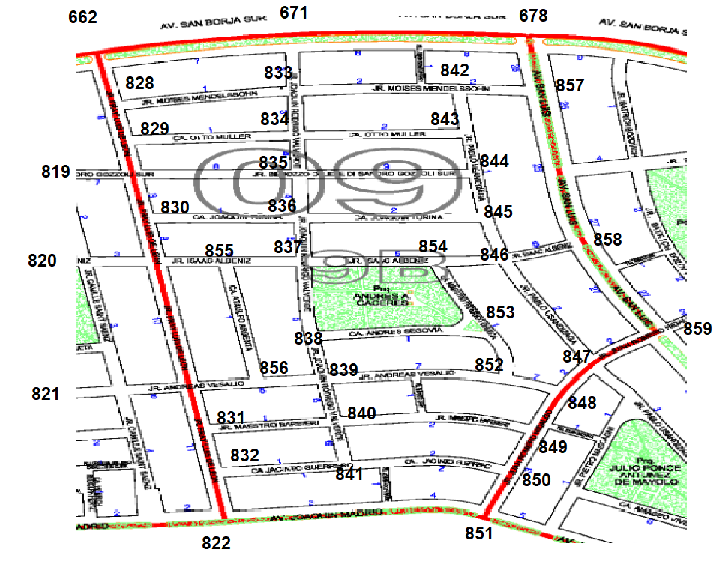

**SECTOR 9B**

[662, 829, 833],#828

[819, 828, 834],#829

[819, 820, 836],#830

[821, 832, 840],#831

[822, 831, 841],#832

[671, 828, 834, 842],#833

[829, 833, 835, 843],#834

[819, 834, 836, 844],#835

[830, 835, 837, 845],#836

[836, 838, 854, 855],#837

[837, 839, 853],#838

[838, 840, 852, 856],#839

[831, 839, 841, 849],#840

[832, 840, 850],#841

[833, 843, 857],#842

[834, 842, 844],#843

[835, 843, 845],#844

[836, 844, 846],#845

[845, 847, 854, 858],#846

[846, 848, 859],#847

[847, 849, 852],#848

[840, 848, 850],#849

[841, 849, 851],#850

[822, 850],#851

[839, 847, 853],#852

[838, 852, 854],#853

[837, 846, 853],#854

[820, 837, 856],#855

[821, 839, 855],#856

[678, 842, 858],#857

[846, 857, 859],#858

[847, 858],#859

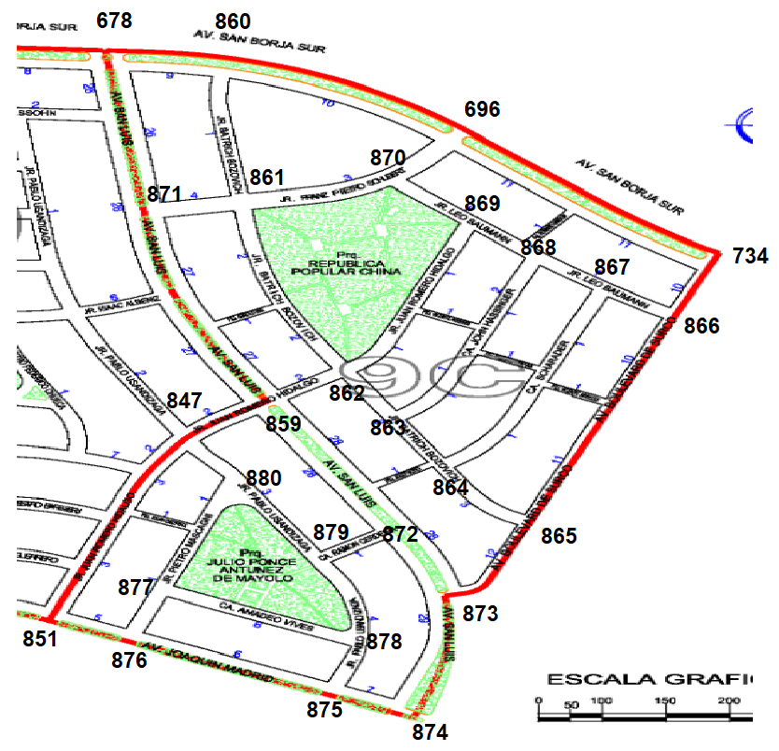

**SECTOR 9C**

[678, 696, 861],#860

[860, 862, 870, 871],#861

[859, 861, 863, 869],#862

[862, 863, 868],#863

[863, 865, 867],#864

[864, 866, 873],#865

[865, 867, 734],#866

[864, 866, 868],#867

[863, 867, 869],#868

[862, 868, 870],#869

[696, 861, 869],#870

[678, 859, 861],#871

[859, 873, 879],#872

[865, 872, 874],#873

[873, 875],#874

[874, 876, 878],#875

[851, 875, 877],#876

[876, 878, 880],#877

[875, 877, 879],#878

[872, 878, 880],#879

[847, 877, 879],#880

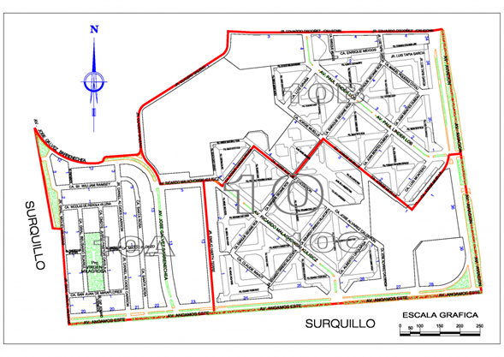

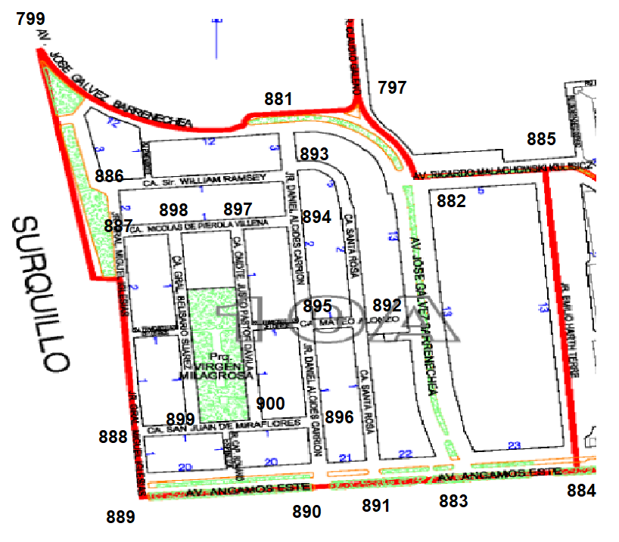

**SECTOR 10A**

[797, 799, 893],#881

[797, 883, 885],#882

[882, 884, 891],#883

[883, 885],#884

[882, 884],#885

[799, 887, 893],#886

[886, 888, 898],#887

[887, 889, 899],#888

[888, 890],#889

[889, 891, 896],#890

[883, 890, 892],#891

[891, 893, 895],#892

[881, 886, 892, 894],#893

[893, 895, 897],#894

[892, 894, 896],#895

[890, 895, 900],#896

[894, 898, 900],#897

[887, 897, 899],#898

[888, 898, 900],#899

[896, 897, 899],#900

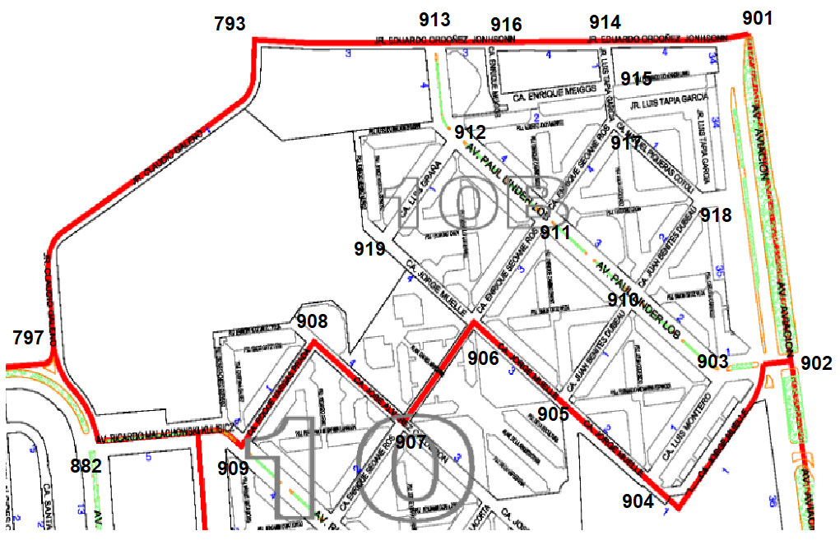

**SECTOR 10B**

[902, 914],#901

[901, 903],#902

[902, 904],#903

[902, 903, 905],#904

[904, 906, 910],#905

[905, 907, 911, 919],#906

[906, 908],#907

[907, 909],#908

[882, 908],#909

[903, 905, 911, 918],#910

[906, 910, 912, 917],#911

[911, 913, 919],#912

[793, 912, 916],#913

[901, 915, 916],#914

[914, 916, 917],#915

[913, 914, 915],#916

[911, 915, 918],#917

[910, 917],#918

[906, 912],#919

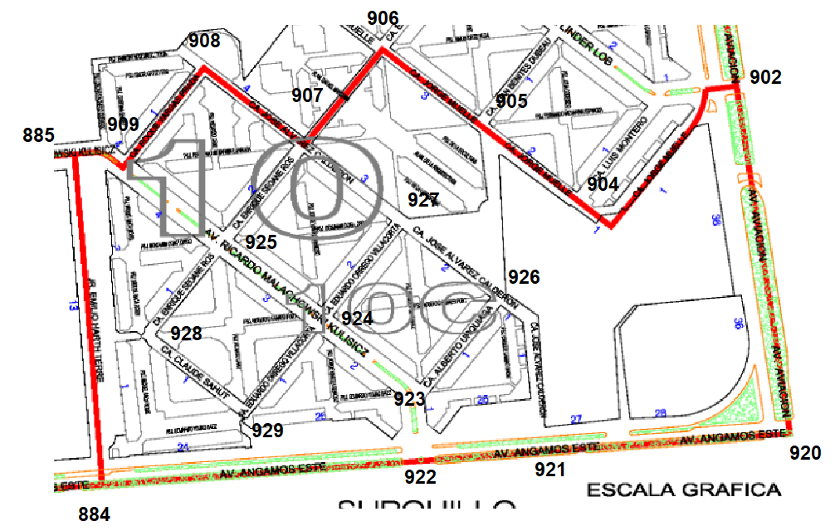

**SECTOR 10C**

[902, 921],#920

[920, 922, 926],#921

[884, 921, 923],#922

[922, 924, 926],#923

[923, 925, 927, 929],#924

[907, 909, 924, 928],#925

[921, 923, 927],#926

[907, 924, 926],#927

[925, 929],#928

[924, 928],#929

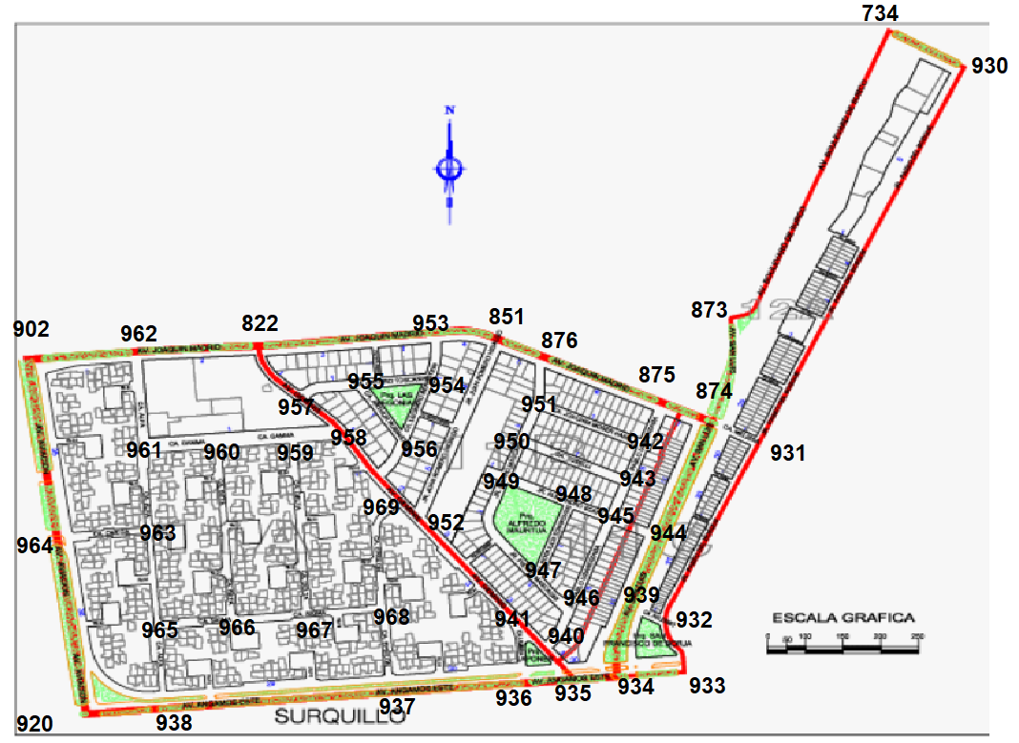

**SECTOR 11**

[734, 931],#930

[874, 930, 932],#931

[931, 933, 939],#932

[932, 934],#933

[933, 935, 939],#934

[934, 936, 940],#935

[935, 937, 941],#936

[936, 938, 968],#937

[920, 937, 965],#938

[932, 934, 944],#939

[935, 941, 946],#940

[936, 940, 952],#941

[875, 943, 951],#942

[942, 945, 950],#943

[874, 939, 945],#944

[943, 944, 946, 948],#945

[940, 945, 947],#946

[946, 948, 949],#947

[945, 947, 949],#948

[947, 948, 950],#949

[943, 949, 951],#950

[876, 942, 950],#951

[851, 941, 969],#952

[822, 851, 954],#953

[953, 955, 956],#954

[954, 956, 957],#955

[954, 955, 969],#956

[822, 955, 958],#957

[957, 959, 969],#958

[958, 960, 967],#959

[959, 961, 966],#960

[960, 962, 963],#961

[822, 902, 961],#962

[961, 964, 965],#963

[902, 920, 963],#964

[938, 963, 966],#965

[960, 965, 967],#966

[959, 966, 968],#967

[937, 967, 969],#968

[952, 958, 968],#969

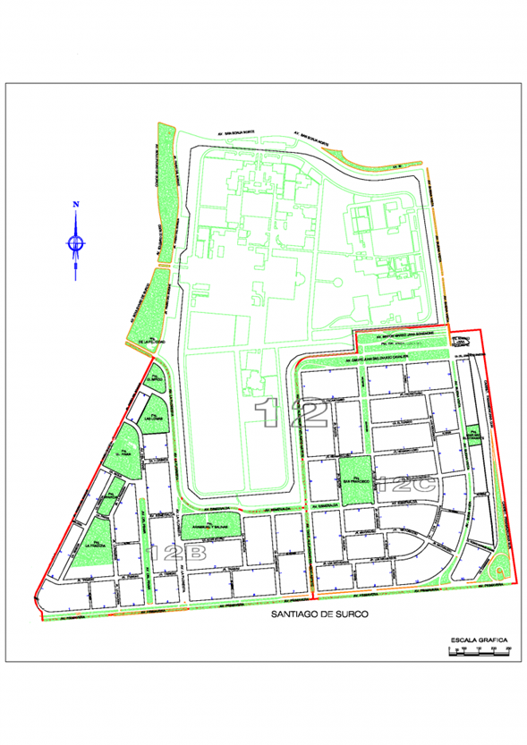

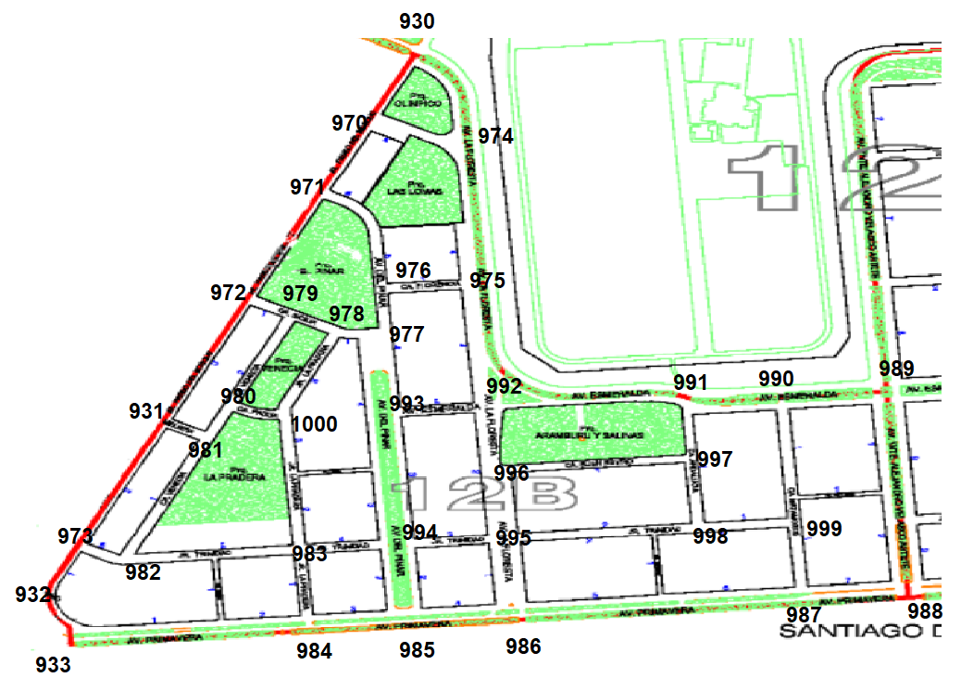

**SECTOR 12B**

[930, 971, 974],#970

[970, 972, 976],#971

[931, 971, 979],#972

[931, 932, 982],#973

[930, 970, 975],#974

[974, 976, 992],#975

[971, 975, 977],#976

[976, 978, 993],#977

[977, 979, 1000],#978

[972, 978, 980],#979

[979, 981, 1000],#980

[931, 980, 982],#981

[973, 981, 983],#982

[982, 984, 994, 1000],#983

[933, 983, 985],#984

[984, 986, 994],#985

[985, 987, 995],#986

[986, 988, 999],#987

[987, 989],#988

[988, 990],#989

[989, 991, 999],#990

[990, 992, 997],#991

[975, 991, 993, 996],#992

[977, 992, 994],#993

[983, 985, 993, 995],#994

[986, 994, 996, 998],#995

[992, 995, 997],#996

[991, 996, 998],#997

[995, 997, 999],#998

[987, 990, 998],#999

[978, 980, 983],#1000

**GRAFO FINAL (TODOS LOS SECTORES)**

**GSB = [**

**#SECTOR1(A,B,C)**

**[1,9], #0**

**[0,2,3], #1**

**[1,4,9], #2**

**[1,4,5], #3**

**[2,3,6], #4**

**[3,6,7], #5**

**[4,5,8], #6**

**[5,8], #7**

**[6,7,14], #8**

**[0,2,10,11], #9**

**[6,9,12], #10**

**[9,12,18], #11**

**[10,11,13], #12**

**[6,12,14,15], #13**

**[8,13,16], #14**

**[13,17,18], #15**

**[14,17,20,37], #16**

**[15,16,20], #17**

**[11,15,19], #18**

**[18,20,21], #19**

**[19,17], #20**

**[19,22,32], #21**

**[21,23,26], #22**

**[22,24,27], #23**

**[23,25,28], #24**

**[24,29,32,39], #25**

**[22,27,30], #26**

**[23,26,28], #27**

**[24,27,29], #28**

**[25,28,31,37], #29**

**[26,42,31], #30**

**[29,30,41], #31**

**[21,25,33], #32**

**[32,34,42,38], #33**

**[33,35,40], #34**

**[34,36,38], #35**

**[35,37,41], #36**

**[16,36,48,52], #37**

**[25,27,40], #38**

**[25,37,40], #39**

**[34,39,38], #40**

**[20,31,36], #41**

**[33,43,44], #42**

**[42,45], #43**

**[42,45,46], #44**

**[43,44,47], #45**

**[44,47,49], #46**

**[45,46,51], #47**

**[33,49,37], #48**

**[48,46,50], #49**

**[49,51,52], #50**

**[47,50,53], #51**

**[37,50,53], #52**

**#SECTOR2(A,B,C)**

**[43, 55],#54**

**[54, 56, 73],#55**

**[53, 55, 75],#56**

**[53, 58, 86],#57**

**[57, 59, 90],#58**

**[58, 60, 92],#59**

**[59, 61],#60**

**[60, 62, 78],#61**

**[61, 63, 85],#62**

**[62, 64, 69],#63**

**[63, 65],#64**

**[64, 66, 67],#65**

**[43, 65, 68],#66**

**[65, 68, 69],#67**

**[54, 66, 67, 71],#68**

**[63, 67, 70, 79],#69**

**[69, 71, 80],#70**

**[68, 70, 72],#71**

**[71, 73, 82],#72**

**[55, 72, 74],#73**

**[73, 75, 83],#74**

**[56, 74, 76],#75**

**[75, 77, 86],#76**

**[76, 78, 84, 88],#77**

**[61, 77, 89],#78**

**[69, 80, 85],#79**

**[70, 79, 81],#80**

**[80, 82, 84],#81**

**[72, 81, 83],#82**

**[74, 82, 84],#83**

**[77, 81, 83, 85],#84**

**[62, 79, 84],#85**

**[57, 76, 87],#86**

**[77, 86, 88, 90],#87**

**[87, 89, 91],#88**

**[78, 88, 92],#89**

**[58, 87, 91],#90**

**[88, 90, 92],#91**

**[59, 89, 91],#92**

**[63, 64, 94],#93**

**[93, 95, 105],#94**

**[63, 94, 96, 98],#95**

**[62, 95, 97],#96**

**[96, 98, 100],#97**

**[95, 97, 99],#98**

**[98, 100, 103],#99**

**[97, 99, 101],#100**

**[100, 102, 116],#101**

**[101, 103, 112],#102**

**[99, 102, 104],#103**

**[103, 105, 111],#104**

**[94, 104, 106],#105**

**[105, 107],#106**

**[106, 108],#107**

**[109, 115],#108**

**[108, 110, 113],#109**

**[109, 111, 113],#110**

**[104, 110, 112],#111**

**[102, 114],#112**

**[109, 114],#113**

**[112, 113, 115, 116],#114**

**[108, 114, 117],#115**

**[101, 114, 117],#116**

**[61, 115, 116],#117**

**[107, 119, 122],#118**

**[118, 130, 149],#119**

**[107, 108, 121],#120**

**[120, 122, 127],#121**

**[118, 121, 123, 126],#122**

**[122, 124, 129],#123**

**[123, 125, 129],#124**

**[108, 124, 126, 141],#125**

**[122, 125, 127],#126**

**[121, 126, 128],#127**

**[108, 120, 127],#128**

**[123, 124, 130, 144],#129**

**[119, 129, 131],#130**

**[130, 132, 145, 149],#131**

**[131, 133, 148],#132**

**[132, 134],#133**

**[133, 135],#134**

**[60, 134],#135**

**[61, 135, 137],#136**

**[134, 136, 138],#137**

**[133, 137, 139]#138 ,**

**[138, 140, 142, 148],#139**

**[139, 141, 146],#140**

**[125, 140, 142, 143],#141**

**[108, 139, 141],#142**

**[141, 144, 146],#143**

**[129, 143, 145],#144**

**[131, 144, 147],#145**

**[140, 143, 147],#146**

**[145, 146, 148],#147**

**[132, 139, 147],#148**

**[119, 131],#149**

**#SECTOR3(A,B,C)**

**[151,167], #150**

**[150,163,152], #151**

**[151,160,153], #152**

**[152,158,154], #153**

**[153,155], #154**

**[154,156,185], #155**

**[155,157,186], #156**

**[156,158,196], #157**

**[153,157,159], #158**

**[158,160,197], #159**

**[15,159,161,193], #160**

**[160,162,198], #161**

**[163,161,199], #162**

**[151,164,162], #163**

**[163,165,201], #164**

**[164,166,201], #165**

**[165,167,202], #166**

**[150,168,166], #167**

**[167,169,170], #168**

**[168,171,204,205], #169**

**[168,171,17], #170**

**[169,170,173,204,208], #171**

**[170,202,178], #172**

**[178,171,174,209,282], #173**

**[173,177,175], #174**

**[174,176], #175**

**[177,179,175], #176**

**[178,174,181,176], #177**

**[172,183,177,173], #178**

**[180,184,176], #179**

**[181,188,179], #180**

**[182,189,177,180], #181**

**[183,190,181], #182**

**[203,182,178], #183**

**[185,187,179], #184**

**[155,186,184], #185**

**[156,185,195], #186**

**[195,192,188,184], #187**

**[189,187,180], #188**

**[190,181,188], #189**

**[191,182,189], #190**

**[194,203,190], #191**

**[197,187,193], #192**

**[194,192,160], #193**

**[198,191,193], #194**

**[186,196,187], #195**

**[157,197,195], #196**

**[159,192,196], #197**

**[199,194,161], #198**

**[162,198,200], #199**

**[201,199,202], #200**

**[164,165,200], #201**

**[166,200,172,203], #202**

**[202,200,183,191], #203**

**[169,171,207], #204**

**[169,206,214], #205**

**[205,207,213,211], #206**

**[204,208,206], #207**

**[171,207,209], #208**

**[208,173,210],279, #209**

**[209,211,219,277], #210**

**[210,206,212], #211**

**[211,213,216], #212**

**[206,215,212], #213**

**[205,222,215], #214**

**[214,213,216,217], #215**

**[214,212,218], #216**

**[215,221,218], #217**

**[216,217,219], #218**

**[218,210,220], #219**

**[219,227,221], #220**

**[222,217,220,225], #221**

**[214,221,223], #222**

**[222,231,224], #223**

**[223,225,230,228], #224**

**[221,224,226], #225**

**[225,228,227], #226**

**[220,226,234], #227**

**[226,229,224], #228**

**[228,230,233], #229**

**[224,232,229], #230**

**[223,238,232], #231**

**[231,230,237,233], #232**

**[229,232,234], #233**

**[233,227,235], #234**

**[234,236,241], #235**

**[237,240,235], #236**

**[232,236,239], #237**

**[231,239], #238**

**[238,237,240], #239**

**[236,239,241], #240**

**[235,240,247], #241**

**[227,243,234],#242**

**[242,284,244],#243**

**[245,254],#244**

**[234,244,246],#245**

**[235,245,248],#246**

**[241,248,249],#247**

**[246,247,250],#248**

**[250,247,251],#249**

**[248,253,249],#250**

**[249,252],#251**

**[254,251,258],#252**

**[254,250,252,257],#253**

**[244,255,253],#254**

**[256,261,257],#255**

**[284,255,262],#256**

**[261,253,258],#257**

**[7257,259,252],#258**

**[260,269,258],#259**

**[267,259,261],#260**

**[255,257,260],#261**

**[256,220,260,264],#262**

**[219,276,264],#263**

**[263,262,275],#264**

**[262,274,266],#265**

**[265,273,267],#266**

**[266,260,268],#267**

**[271,267,269],#268**

**[268,259,270],#269**

**[283,271,269],#270**

**[280,272,268,270],#271**

**[273,278,271],#272**

**[272,274,266],#273**

**[273,275,265],#274**

**[276,264,274],#275**

**[277,263,275],#276**

**[210,276,278],#277**

**[279,272,277],#278**

**[282,278,209,280],#279**

**[279,281,271],#280**

**[282,280,283],#281**

**[173,279,281],#282**

**[281,270],#283**

**[227,243,256],#284**

**#SECTOR4(A,B,C)**

**[287,286],#285**

**[285,289,292],#286**

**[285,344,288],#287**

**[287,289,339],#288**

**[288,286,290,338],#289**

**[289,337,291],#290**

**[290,292,329,301],#291**

**[286,291,293],#292**

**[292,294,295],#293**

**[301,293,297],#294**

**[293,296],#295**

**[295,297,307],#296**

**[294,298,296],#297**

**[297,299,306],#298**

**[300,304,298],#299**

**[302,299,303],#300**

**[291,294,302],#301**

**[300,301,319],#302**

**[300,304,318],#303**

**[303,299,305],#304**

**[304,318,312,306],#305**

**[305,298,309,307],#306**

**[306,296,308],#307**

**[308,309,408],#308**

**[306,308,310,410,323],#309**

**[311,309,315],#310**

**[312,314,310],#311**

**[305,313,311],#312**

**[317,314,312],#313**

**[313,315,311],#314**

**[314,316,310],#315**

**[315,317,323],#316**

**[322,316,313],#317**

**[305,303,319],#318**

**[320,302,318],#319**

**[337,291,319,321],#320**

**[320,322,325],#321**

**[321,317,323],#322**

**[322,324,316,417,309],#323**

**[325,328,324,323,390,329],#324**

**[321,326,324],#325**

**[336,325,327],#326**

**[326,330,328],#327**

**[324,327,329],#328**

**[330,328,331,389,324],#329**

**[334,327,329],#330**

**[332,333,329,346],#331**

**[342,331,345],#332**

**[341,334,331],#333**

**[335,333,330],#334**

**[340,336,334],#335**

**[337,334,326],#336**

**[338,290,336,320],#337**

**[3289,339,337],#338**

**[344,288,340,338],#339**

**[339,335,341],#340**

**[340,342,333],#341**

**[344,341,332],#342**

**[340,290],#343**

**[287,342,339],#344**

**[332,346,347],#345**

**[345,331,349,389],#346**

**[345,352,348],#347**

**[347,350,349],#348**

**[348,346,357,379],#349**

**[348,351,356],#350**

**[352,350,355],#351**

**[347,351,353],#352**

**[352,354,365],#353**

**[355,353,360,363,364],#354**

**[351,356,354],#355**

**[350,355,357],#356**

**[349,356,358,378],#357**

**[359,357,375],#358**

**[357,358,360],#359**

**[354,359,361],#360**

**[362,360,371,372],#361**

**[361,364,367,369],#362**

**[364,354,365,367],#363**

**[354,363,362],#364**

**[353,363,366],#365**

**[365,367,368],#366**

**[363,366,362],#367**

**[366,369],#368**

**[368,362,370],#369**

**[371,369,374],#370**

**[361,370,373],#371**

**[359,361,375],#372**

**[371,375,374,384],#373**

**[370,373,385],#374**

**[372,358,373,376],#375**

**[375,377,382],#376**

**[378,381,376],#377**

**[377,357,379],#378**

**[349,378,380],#379**

**[379,381,387],#380**

**[377,382,386,380],#381**

**[376,381,383],#382**

**[382,386,384],#383**

**[385,373,383,393,395],#384**

**[383,374,397],#385**

**[383,381,387,392],#386**

**[380,385,389,386,391],#387**

**[389,387],#388**

**[329,346,387,388,390],#389**

**[389,324,418],#390**

**[387,392,418,390],#391**

**[391,393,386],#392**

**[392,394,419],#393**

**[393,400,395],#394**

**[394,384,396],#395**

**[395,397,400,399],#396**

**[396,385,398],#397**

**[397,399,404],#398**

**[398,396,402,403],#399**

**[401,396,394],#400**

**[400,402,419],#401**

**[401,399,414,415],#402**

**[414,499,404,407],#403**

**[398,305,403],#404**

**[405,406],#405**

**[405,407,408],#406**

**[406,403,409],#407**

**[406,409,309],#408**

**[408,410,412,407],#409**

**[417,412,410],#411**

**[411,416,413,409],#412**

**[412,415,414],#413**

**[413,402,403],#414**

**[416,413,402],#415**

**[418,417,415,412],#416**

**[323,411,416],#417**

**[390,416,419,391],#418**

**[418,393,401],#419**

**#SECTOR5(A,B,C)**

**[422,421,455],#420**

**[420,423,442],#421**

**[420],#422**

**[424,421,427],#423**

**[423,425],#424**

**[424,426,428],#425**

**[425,430],#426**

**[423,428,431],#427**

**[425,429,427,432],#428**

**[430,428,434],#429**

**[429,435,426],#430**

**[427,432,440,442],#431**

**[431,433,428],#432**

**[432,434,441],#433**

**[429,433,435,537],#434**

**[430,434,436],#435**

**[437,435,451],#436**

**[438,434,436,450],#437**

**[441,439,437,449],#438**

**[440,438,444],#439**

**[431,441,439],#440**

**[433,440,438],#441**

**[431,443,421,452],#442**

**[442,444,462,445],#443**

**[443,439,445],#444**

**[444,446,443,463,447],#445**

**[445,449,447],#446**

**[446,450,448,445,474],**

**[447,451],#448[447,425],#448**

**[446,450,438],#449**

**[449,437,451,447],#450**

**[450,436,448],#451**

**[453,442],#452**

**[454,452,456],#453**

**[455,453],#454**

**[420,454],#455**

**[453,457,459],#456**

**[456,458],#457**

**[457,459],#458**

**[456,458,460],#459**

**[459,461],#460**

**[460,462,465],#461**

**[461,443,463],#462**

**[462,445,472,464],#463**

**[463,465,461,471],#464**

**[461,464,466],#465**

**[465,470,467],#466**

**[465,460,468],#467**

**[467,469],#468**

**[468,470,473],#469**

**[466,470,469],#470**

**[470,464,472],#471**

**[471,463,473],#472**

**[469,472,474],#473**

**[447,475,473],#474**

**[474,448],#475**

**[454,453,479,478],#476**

**[478,476,483],#477**

**[479,477,482],#478**

**[478,476,480],#479**

**[479,481,488],#480**

**[480,486,478],#481**

**[478,483,484],#482**

**[482,477,468],#483**

**[482,485,490],#484**

**[484,486],#485**

**[481,485,487],#486**

**[486,488,490],#487**

**[489,485,480],#488**

**[488,455],#489**

**[487,484,468],#490**

**[469,492,468],#491**

**[473,491,493],#492**

**[492,495,494],#493**

**[473,493,496],#494**

**[493,497],#495**

**[494,497,499],#496**

**[495,496,498],#497**

**[497,499,500],#498**

**[498,496,501],#499**

**[498,502],#500**

**[499,502],#501**

**[500,501],#502**

**#SECTOR6(A,B,C)**

**[154, 155, 513, 514, 515],#503**

**[154, 505, 514],#504**

**[504, 506, 512],#505**

**[505, 507, 511],#506**

**[506, 508],#507**

**[507, 509, 511],#508**

**[508, 510, 513],#509**

**[509, 515],#510**

**[506, 508, 512],#511**

**[505, 511, 513],#512**

**[509, 512, 515],#513**

**[503, 504, 512, 515],#514**

**[503, 510, 513],#515**

**[155, 185, 518],#516**

**[184, 185, 535],#517**

**[516, 519, 535],#518**

**[518, 520, 539],#519**

**[515, 519, 521, 540],#520**

**[515, 522, 541],#521**

**[521, 523, 544],#522**

**[522, 524, 525],#523**

**[510, 515, 523],#524**

**[523, 526, 527, 543],#525**

**[510, 525, 545],#526**

**[525, 528, 529],#527**

**[527, 530, 545],#528**

**[527, 530, 540],#529**

**[528, 529, 531],#530**

**[530, 532, 533],#531**

**[531, 534, 537],#532**

**[184, 531, 534],#533**

**[532, 533, 535],#534**

**[517, 518, 534, 536],#535**

**[535, 537, 539],#536**

**[532, 536, 538],#537**

**[537, 539, 540],#538**

**[519, 536, 538],#539**

**[520, 530, 537, 541],#540**

**[521, 540, 542],#541**

**[541, 543, 544],#542**

**[525, 542, 544],#543**

**[522, 542, 543],#544**

**[526, 528],#545**

**[175, 184, 547],#546**

**[546, 548, 567],#547**

**[533, 547, 549],#548**

**[548, 550, 568],#549**

**[551, 569],#550**

**[531, 550, 552, 572],#551**

**[551, 553, 573],#552**

**[530, 552, 554, 578],#553**

**[553, 555, 579],#554**

**[554, 556, 580],#555**

**[555, 557, 581],#556**

**[528, 556, 558],#557**

**[557, 559, 566, 581],#558**

**[558, 560, 582],#559**

**[559, 562, 577, 581],#560**

**[562, 582],#561**

**[560, 561, 563],#562**

**[562, 564, 575],#563**

**[563, 565, 570],#564**

**[175, 564, 567],#565**

**[545, 558, 582],#566**

**[547, 565, 568],#567**

**[549, 567, 569],#568**

**[550, 568, 570],#569**

**[564, 569, 571],#570**

**[570, 572, 574],#571**

**[551, 571, 573],#572**

**[552, 572, 574, 578],#573**

**[571, 573, 575],#574**

**[563, 574, 576, 578],#575**

**[575, 577, 579],#576**

**[560, 576, 580],#577**

**[553, 573, 575, 579],#578**

**[554, 576, 578, 580],#579**

**[555, 577, 579, 581],#580**

**[556, 558, 560, 580],#581**

**[559, 561, 566],#582**

**#SECTOR7(A,B,C)**

**[584,585],#583**

**[583,588],#584**

**[583,586,621],#585**

**[585,587,610,609],#586**

**[588,607,586],#587**

**[584,600,587],#588**

**[560,600,592],#589**

**[600,591,593],#590**

**[590,592,594],#591**

**[592,591,589,596],#592**

**[590,592,594],#593**

**[593,595,591],#594**

**[594,596],#595**

**[595,592,598,596],#596**

**[596,598],#597**

**[597,596,599],#598**

**[584,599,600,604],#599**

**[601,588,607],#600**

**[599,602,600],#601**

**[601,606,603],#602**

**[602,604,605,642],#603**

**[599,603,648],#604**

**[606,603,640],#605**

**[607,605,602],#606**

**[600,587,606,608],#607**

**[600,612,607,586,638],#608**

**[608,614,610],#609**

**[586,615,611],#610**

**[609,610,614],#611**

**[612,608,613,637],#612**

**[612,614,617,636],#613**

**[611,616,613],#614**

**[610,616,622],#615**

**[615,614,620,617],#616**

**[613,618,616],#617**

**[619,617,635],#618**

**[617,618,620,624],#619**

**[616,623,619],#620**

**[585,622],#621**

**[621,615,623,628],#622**

**[620,622,625,624],#623**

**[619,627,623,682],#624**

**[623,629,626],#625**

**[625,631,627],#626**

**[624,626,630,709],#627**

**[622,629,634],#628**

**[625,628,633],#629**

**[627,631,708],#630**

**[626,632,630],#631**

**[633,631,711],#632**

**[634,629,632,712],#633**

**[628,633,713],#634**

**[618],#635**

**[613],#636**

**[612],#637**

**[608],#638**

**[640],#639**

**[605,641,645,639],#640**

**[642,640,644],#641**

**[603,641,643],#642**

**[647,642,644],#643**

**[643,641,645],#644**

**[644,646,640,656],#645**

**[645,667],#646**

**[643,658,656,649],#647**

**[604,647,651],#648**

**[647,650,655],#649**

**[649,655,651,654],#650**

**[548,650,652],#651**

**[651,653],#652**

**[652,662,654],#653**

**[650,657,653],#654**

**[656,650,657,649],#655**

**[647,645,659,655],#656**

**[659,655,658,654],#657**

**[657,653],#658**

**[657,660,656],#659**

**[659,665,661],#660**

**[662,663,660],#661**

**[661,671,653],#662**

**[661,664,672],#663**

**[665,670,663],#664**

**[660,666,667,669,664],#665**

**[665,667],#666**

**[666,646,668,665],#667**

**[669,675,667],#668**

**[670,674,665],#669**

**[669,672,664],#670**

**[672,662,678],#671**

**[663,670,673],#672**

**[672,674,677],#673**

**[673,669,676],#674**

**[668,676],#675**

**[674,675,681,677],#676**

**[673,676],#677**

**[679,671,691],#678**

**[680,678,690],#679**

**[679,676,681],#680**

**[676,680,682],#681**

**[681,624],#682**

**[681,689],#680**

**[688,682],#681**

**[683,624],#682**

**[682,684,686],#683**

**[683,685,687],#684**

**[684,708],#685**

**[683,687],#686**

**[686,684,688],#687**

**[687,681,695,694,689],#688**

**[688,693,680,690],#689**

**[689,692,679],#690**

**[692,678,696],#691**

**[691,690,693,697],#692**

**[694,689,698,692],#693**

**[693,703,688,699],#694**

**[694,703,688],#695**

**[697,691,734],#696**

**[696,692,733,698],#697**

**[699,732,697,693],#698**

**[700,731,698,693],#699**

**[729,701,699,703],#700**

**[700,702,728],#701**

**[701,704,723],#702**

**[696,704,700],#703**

**[725,723,728],#704**

**[706,710,704],#705**

**[707,705],#706**

**[708,710,706],#707**

**[707,630],#708**

**[701,705],#709**

**[709,707,711],#710**

**[710,715,632,626,720],#711**

**[633,713,715],#712**

**[714,712,634],#713**

**[713,716,715],#714**

**[714,712,718,711],#715**

**[714,717,718],#716**

**[716,719],#717**

**[716,715,719,720],#718**

**[717,722,718],#719**

**[721,718,726,714],#720**

**[720,723,722],#721**

**[719,721,725],#722**

**[721,724,702],#723**

**[723,725,728],#724**

**[724,727,722],#725**

**[720,714,704],#726**

**[725,729,728],#727**

**[701,724,727],#728**

**[727,730,700],#729**

**[731,729,734],#730**

**[730,732,699],#731**

**[731,698,733],#732**

**[732,697],#733**

**[696,730],#734**

**#SECTOR8(A,B,C)**

**[507, 509, 510, 746, 748],#735**

**[510, 545, 745],#736**

**[738, 739, 745],#737**

**[545, 737, 759],#738**

**[737, 740, 742],#739**

**[739, 741, 745, 747],#740**

**[740, 742, 743],#741**

**[739, 741, 744],#742**

**[741, 744, 752],#743**

**[742, 743, 754],#744**

**[736, 737, 740, 746],#745**

**[735, 745, 747, 750],#746**

**[740, 746, 752],#747**

**[507, 735, 746, 749],#748**

**[748, 750],#749**

**[746, 749, 751, 753],#750**

**[750, 756],#751**

**[743, 747, 753],#752**

**[750, 752, 754, 755],#753**

**[744, 753, 759],#754**

**[753, 756, 758],#755**

**[751, 755, 757],#756**

**[756, 758],#757**

**[755, 757, 759],#758**

**[738, 754, 758],#759**

**[545, 582, 772],#760**

**[738, 762, 773],#761**

**[759, 761, 763, 774],#762**

**[757, 762, 775],#763**

**[757, 765],#764**

**[764, 766, 775],#765**

**[765, 767, 786],#766**

**[766, 768],#767**

**[767, 769, 785],#768**

**[768, 770, 782],#769**

**[561, 769, 771],#770**

**[582, 770, 772, 781],#771**

**[760, 771, 773, 780],#772**

**[761, 772, 774],#773**

**[763, 773, 775, 778],#774**

**[763, 765, 774, 776],#775**

**[775, 777, 786],#776**

**[776, 778, 784],#777**

**[774, 777, 779, 783],#778**

**[778, 780, 782],#779**

**[772, 779, 781],#780**

**[771, 780, 782],#781**

**[769, 779, 781, 783],#782**

**[778, 782, 784],#783**

**[777, 783, 785],#784**

**[768, 784, 786],#785**

**[766, 776, 785],#786**

**[507, 749, 789],#787**

**[749, 787, 790],#788**

**[787, 790, 799],#789**

**[788, 789, 791],#790**

**[790, 792, 795, 800],#791**

**[791, 793, 794, 796],#792**

**[757, 792, 794],#793**

**[792, 793, 795],#794**

**[751, 794, 794],#795**

**[792, 797, 800],#796**

**[796, 798],#797**

**[797, 799, 801],#798**

**[789, 798, 801],#799**

**[791, 796, 801],#800**

**[798, 799, 800],#801**

**#SECTOR9(A,B,C)**

**[662, 803, 817],#802**

**[653, 802, 804],#803**

**[803, 805, 818],#804**

**[653, 803, 806],#805**

**[770, 805, 807, 818],#806**

**[806, 808, 816],#807**

**[769, 807, 809, 814],#808**

**[768, 808, 810],#809**

**[809, 811, 813],#810**

**[810, 812, 821, 827],#811**

**[811, 813, 815],#812**

**[810, 812, 814],#813**

**[808, 813, 815],#814**

**[812, 814, 816, 820],#815**

**[807, 815, 817],#816**

**[802, 816, 818, 819],#817**

**[804, 806, 817],#818**

**[662, 817, 820],#819**

**[815, 819, 821],#820**

**[811, 820, 822],#821**

**[821, 823],#822**

**[822, 824, 827],#823**

**[823, 825, 826],#824**

**[824],#825**

**[767, 824],#826**

**[767, 811, 823],#827**

**[662, 829, 833],#828**

**[819, 828, 834],#829**

**[819, 820, 836],#830**

**[821, 832, 840],#831**

**[822, 831, 841],#832**

**[671, 828, 834, 842],#833**

**[829, 833, 835, 843],#834**

**[819, 834, 836, 844],#835**

**[830, 835, 837, 845],#836**

**[836, 838, 854, 855],#837**

**[837, 839, 853],#838**

**[838, 840, 852, 856],#839**

**[831, 839, 841, 849],#840**

**[832, 840, 850],#841**

**[833, 843, 857],#842**

**[834, 842, 844],#843**

**[835, 843, 845],#844**

**[836, 844, 846],#845**

**[845, 847, 854, 858],#846**

**[846, 848, 859],#847**

**[847, 849, 852],#848**

**[840, 848, 850],#849**

**[841, 849, 851],#850**

**[822, 850],#851**

**[839, 847, 853],#852**

**[838, 852, 854],#853**

**[837, 846, 853],#854**

**[820, 837, 856],#855**

**[821, 839, 855],#856**

**[678, 842, 858],#857**

**[846, 857, 859],#858**

**[847, 858],#859**

**[678, 696, 861],#860**

**[860, 862, 870, 871],#861**

**[859, 861, 863, 869],#862**

**[862, 863, 868],#863**

**[863, 865, 867],#864**

**[864, 866, 873],#865**

**[865, 867, 734],#866**

**[864, 866, 868],#867**

**[863, 867, 869],#868**

**[862, 868, 870],#869**

**[696, 861, 869],#870**

**[678, 859, 861],#871**

**[859, 873, 879],#872**

**[865, 872, 874],#873**

**[873, 875],#874**

**[874, 876, 878],#875**

**[851, 875, 877],#876**

**[876, 878, 880],#877**

**[875, 877, 879],#878**

**[872, 878, 880],#879**

**[847, 877, 879],#880**

**#SECTOR10(A,B,C)**

**[797, 799, 893],#881**

**[797, 883, 885],#882**

**[882, 884, 891],#883**

**[883, 885],#884**

**[882, 884],#885**

**[799, 887, 893],#886**

**[886, 888, 898],#887**

**[887, 889, 899],#888**

**[888, 890],#889**

**[889, 891, 896],#890**

**[883, 890, 892],#891**

**[891, 893, 895],#892**

**[881, 886, 892, 894],#893**

**[893, 895, 897],#894**

**[892, 894, 896],#895**

**[890, 895, 900],#896**

**[894, 898, 900],#897**

**[887, 897, 899],#898**

**[888, 898, 900],#899**

**[896, 897, 899],#900**

**[902, 914],#901**

**[901, 903],#902**

**[902, 904],#903**

**[902, 903, 905],#904**

**[904, 906, 910],#905**

**[905, 907, 911, 919],#906**

**[906, 908],#907**

**[907, 909],#908**

**[882, 908],#909**

**[903, 905, 911, 918],#910**

**[906, 910, 912, 917],#911**

**[911, 913, 919],#912**

**[793, 912, 916],#913**

**[901, 915, 916],#914**

**[914, 916, 917],#915**

**[913, 914, 915],#916**

**[911, 915, 918],#917**

**[910, 917],#918**

**[906, 912],#919**

**[902, 921],#920**

**[920, 922, 926],#921**

**[884, 921, 923],#922**

**[922, 924, 926],#923**

**[923, 925, 927, 929],#924**

**[907, 909, 924, 928],#925**

**[921, 923, 927],#926**

**[907, 924, 926],#927**

**[925, 929],#928**

**[924, 928],#929**

**#SECTOR 11**

**[734, 931],#930**

**[874, 930, 932],#931**

**[931, 933, 939],#932**

**[932, 934],#933**

**[933, 935, 939],#934**

**[934, 936, 940],#935**

**[935, 937, 941],#936**

**[936, 938, 968],#937**

**[920, 937, 965],#938**

**[932, 934, 944],#939**

**[935, 941, 946],#940**

**[936, 940, 952],#941**

**[875, 943, 951],#942**

**[942, 945, 950],#943**

**[874, 939, 945],#944**

**[943, 944, 946, 948],#945**

**[940, 945, 947],#946**

**[946, 948, 949],#947**

**[945, 947, 949],#948**

**[947, 948, 950],#949**

**[943, 949, 951],#950**

**[876, 942, 950],#951**

**[851, 941, 969],#952**

**[822, 851, 954],#953**

**[953, 955, 956],#954**

**[954, 956, 957],#955**

**[954, 955, 969],#956**

**[822, 955, 958],#957**

**[957, 959, 969],#958**

**[958, 960, 967],#959**

**[959, 961, 966],#960**

**[960, 962, 963],#961**

**[822, 902, 961],#962**

**[961, 964, 965],#963**

**[902, 920, 963],#964**

**[938, 963, 966],#965**

**[960, 965, 967],#966**

**[959, 966, 968],#967**

**[937, 967, 969],#968**

**[952, 958, 968],#969**

**#SECTOR 12B**

**[930, 971, 974],#970**

**[970, 972, 976],#971**

**[931, 971, 979],#972**

**[931, 932, 982],#973**

**[930, 970, 975],#974**

**[974, 976, 992],#975**

**[971, 975, 977],#976**

**[976, 978, 993],#977**

**[977, 979, 1000],#978**

**[972, 978, 980],#979**

**[979, 981, 1000],#980**

**[931, 980, 982],#981**

**[973, 981, 983],#982**

**[982, 984, 994, 1000],#983**

**[933, 983, 985],#984**

**[984, 986, 994],#985**

**[985, 987, 995],#986**

**[986, 988, 999],#987**

**[987, 989],#988**

**[988, 990],#989**

**[989, 991, 999],#990**

**[990, 992, 997],#991**

**[975, 991, 993, 996],#992**

**[977, 992, 994],#993**

**[983, 985, 993, 995],#994**

**[986, 994, 996, 998],#995**

**[992, 995, 997],#996**

**[991, 996, 998],#997**

**[995, 997, 999],#998**

**[987, 990, 998],#999**

**[978, 980, 983],#1000**

**]**

**Video exposición**

[**https://www.youtube.com/watch?v=tVb5XeIQIbc**](https://www.youtube.com/watch?v=tVb5XeIQIbc)

**Bibliografía**

[**http://www.munisanborja.gob.pe/mapa-sectorizado/**](http://www.munisanborja.gob.pe/mapa-sectorizado/)